Interview Q & A

1. Download binary zip for maven installation
2. Extract in C:/ProgrammFiles/Maven

3) Set Path for maven varaibles

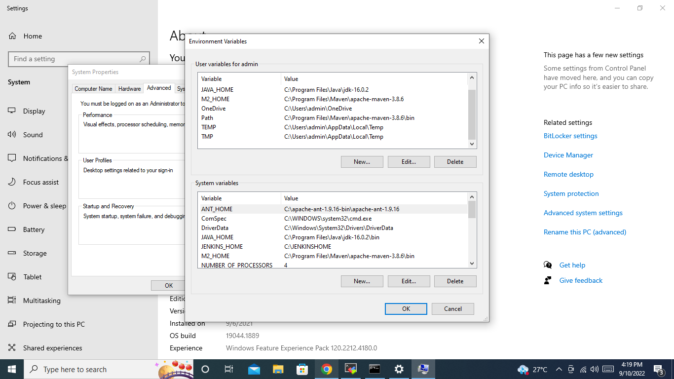

1. Check installation of path using echo %MAVEN_HOME%

-🡪 it shows the installation path

4) check using mvn –v

🡪 it shows the maven version

Mvn install -> it downloads all the dependencies and plugins

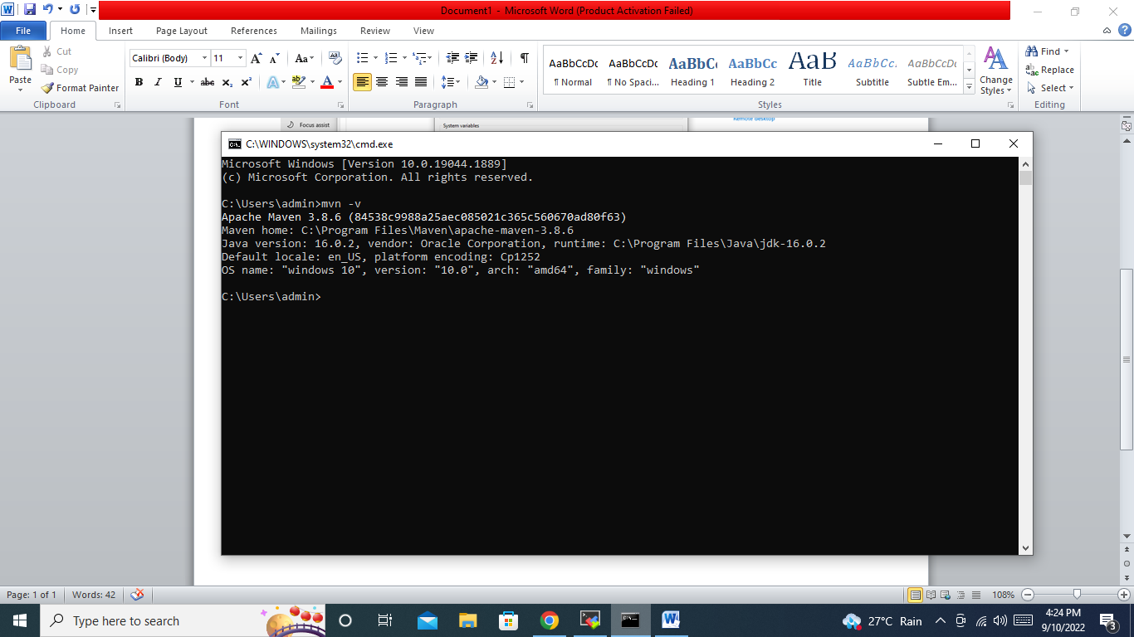

# mvn clean install

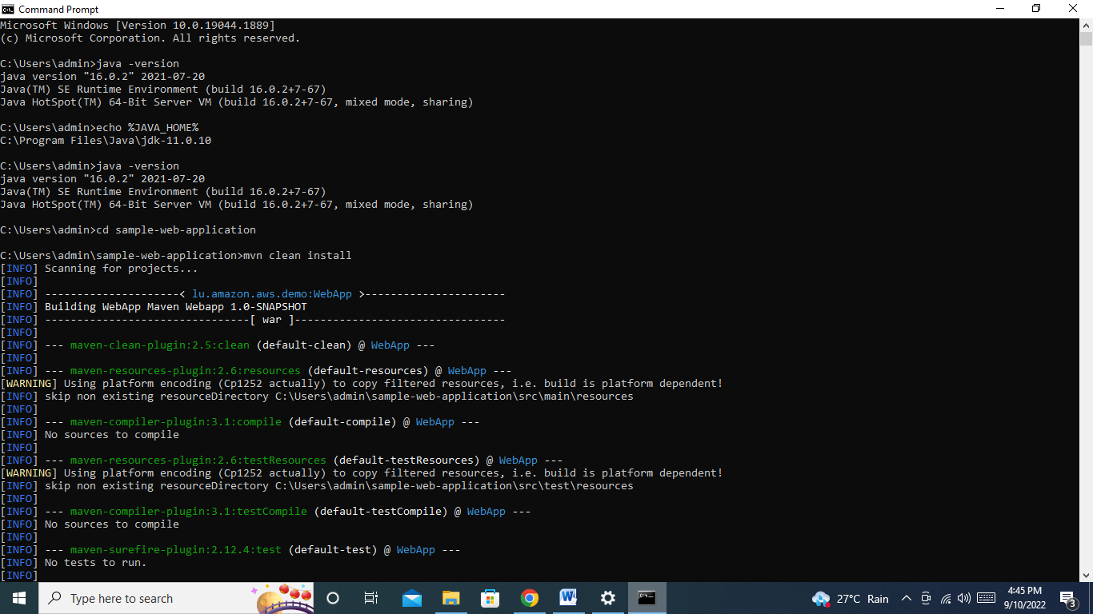

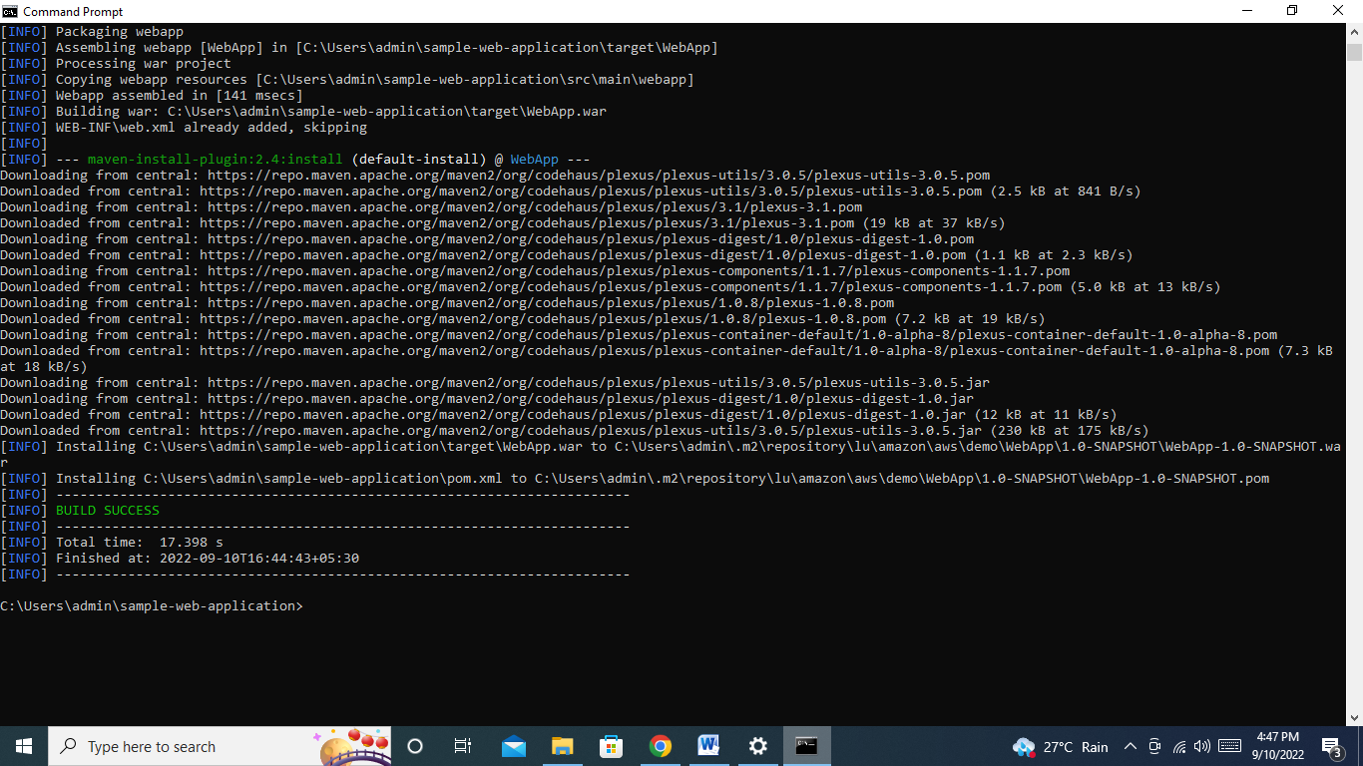

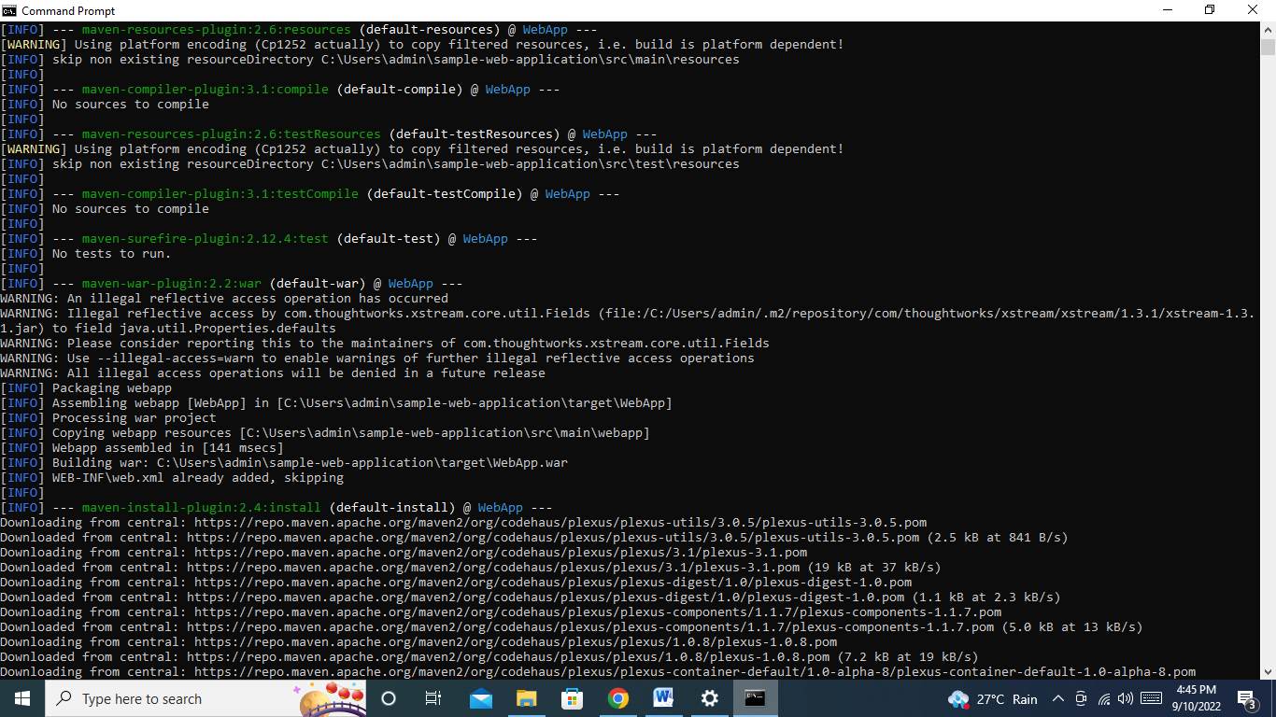

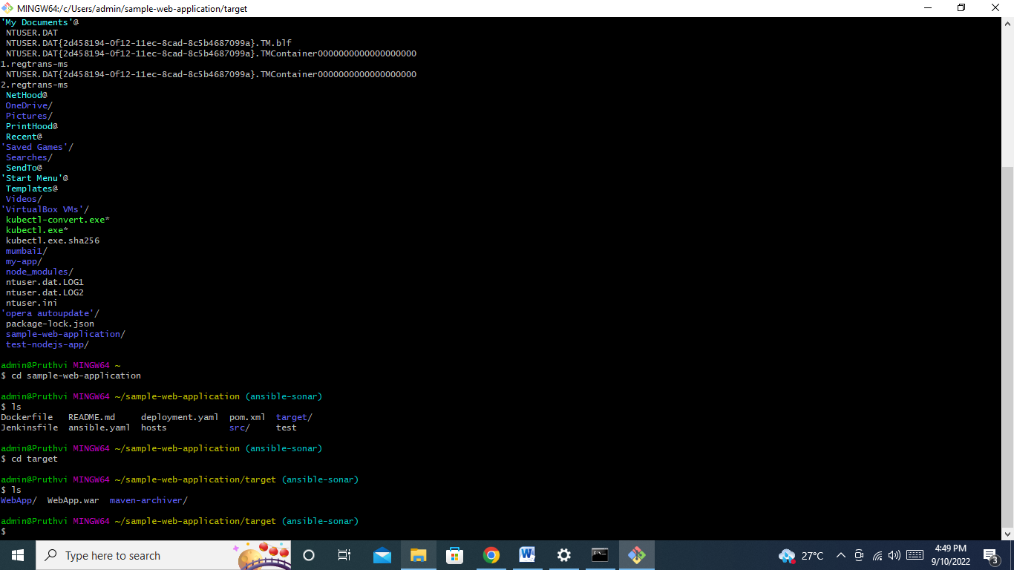

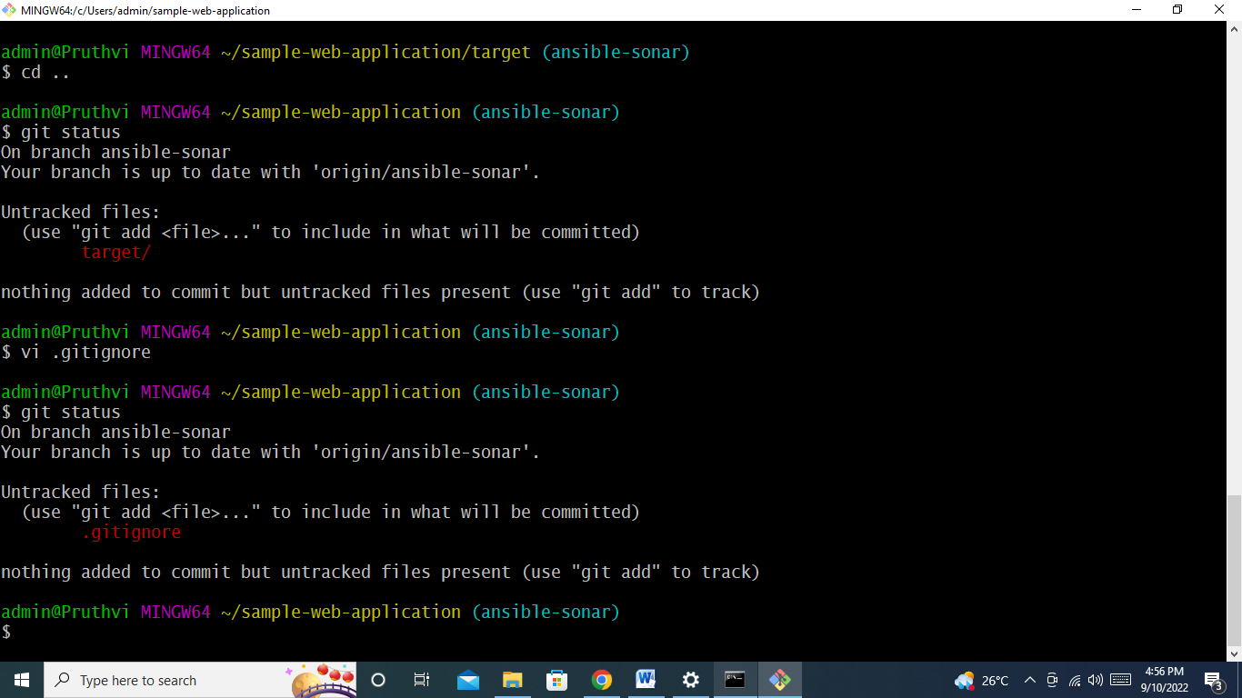

**Q.2 ) Difference between git pull and git fetch**

I have change T to t in README.md file

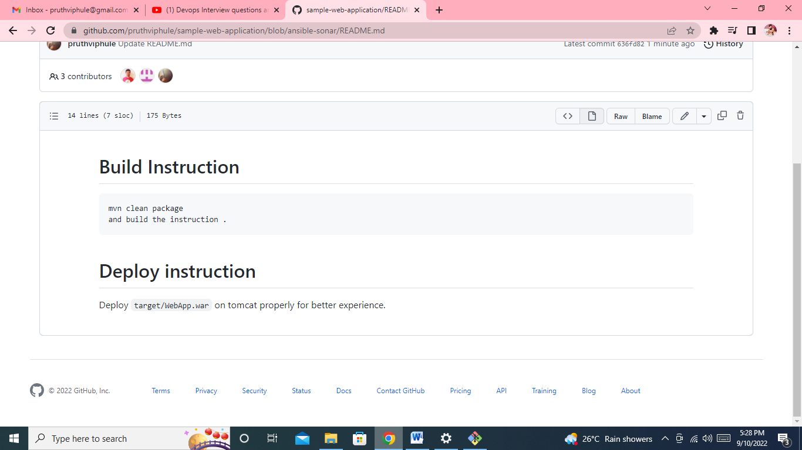

But it not reflect in local, from git fetch

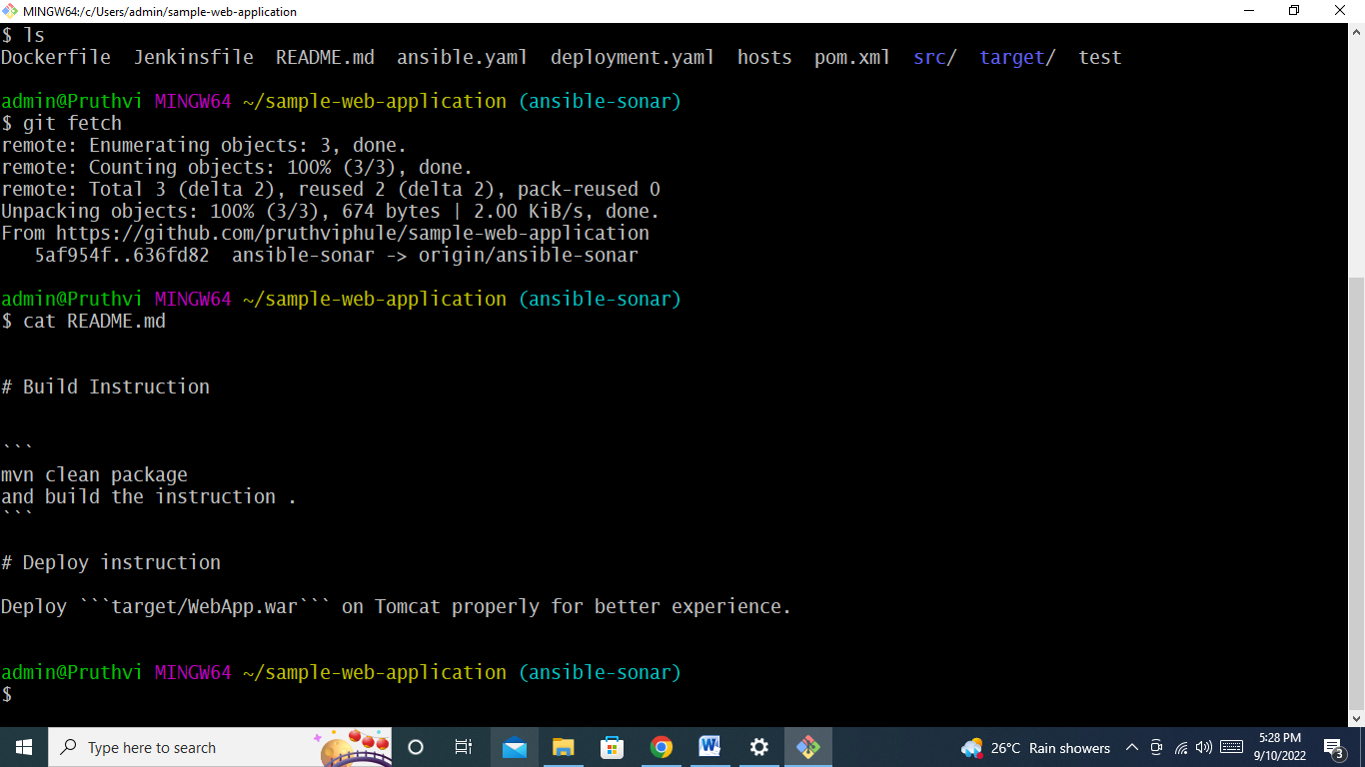

Now go to origin, and make git checkout origin/ansible-sonar then it make chnages

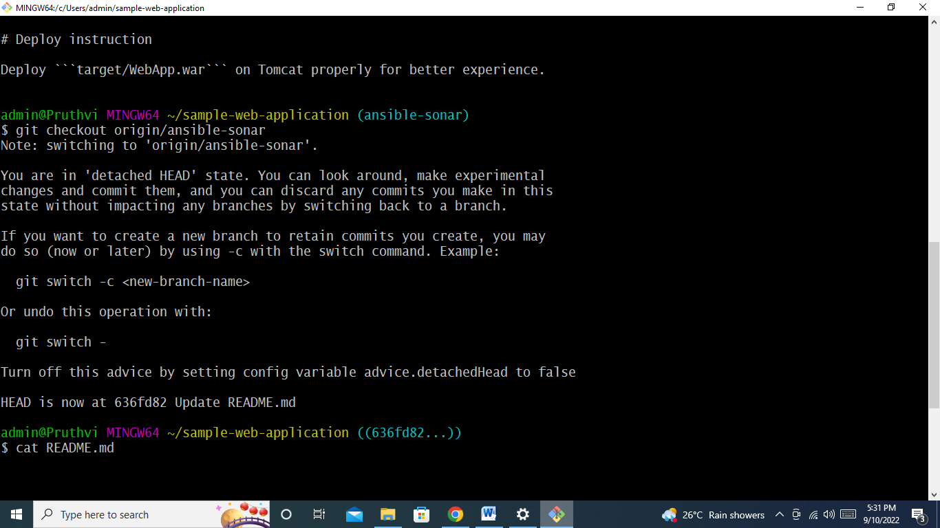

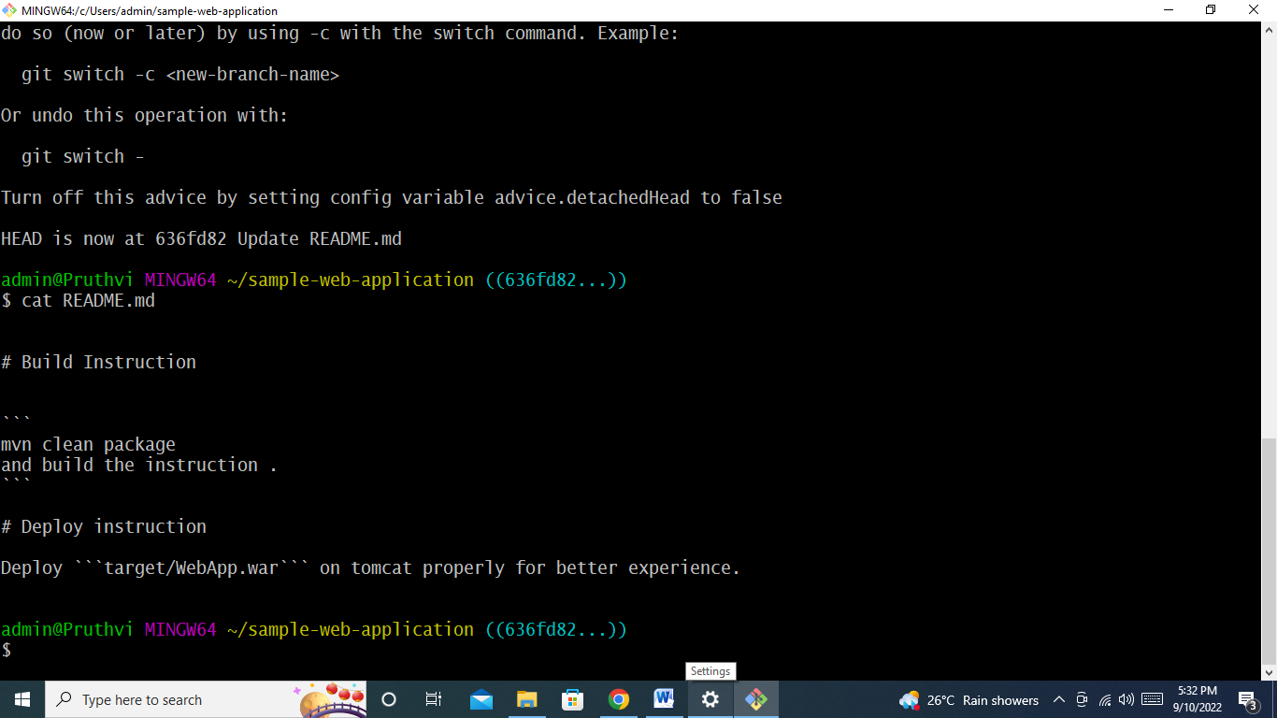

Now check on local

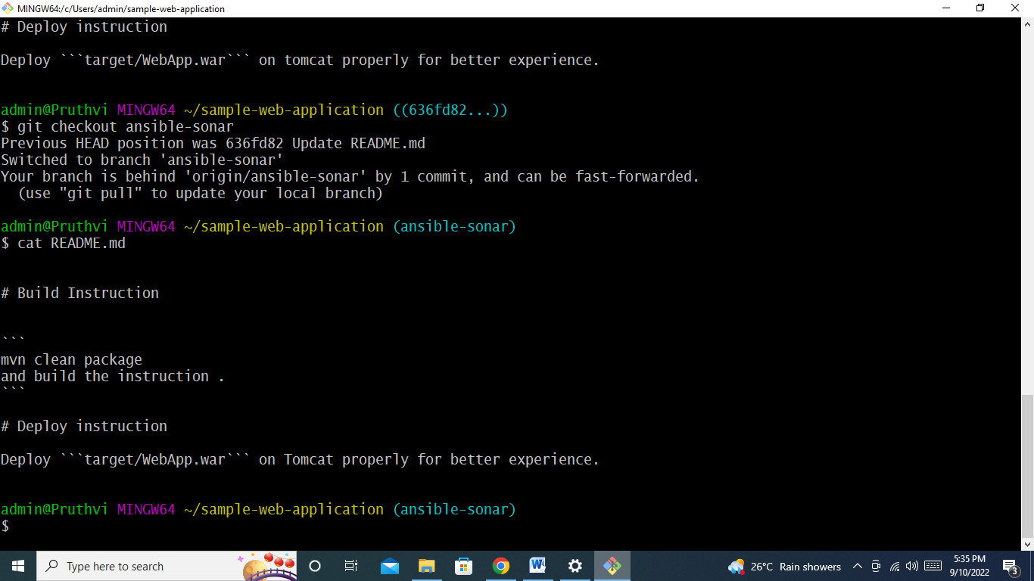

Need to perform git merge

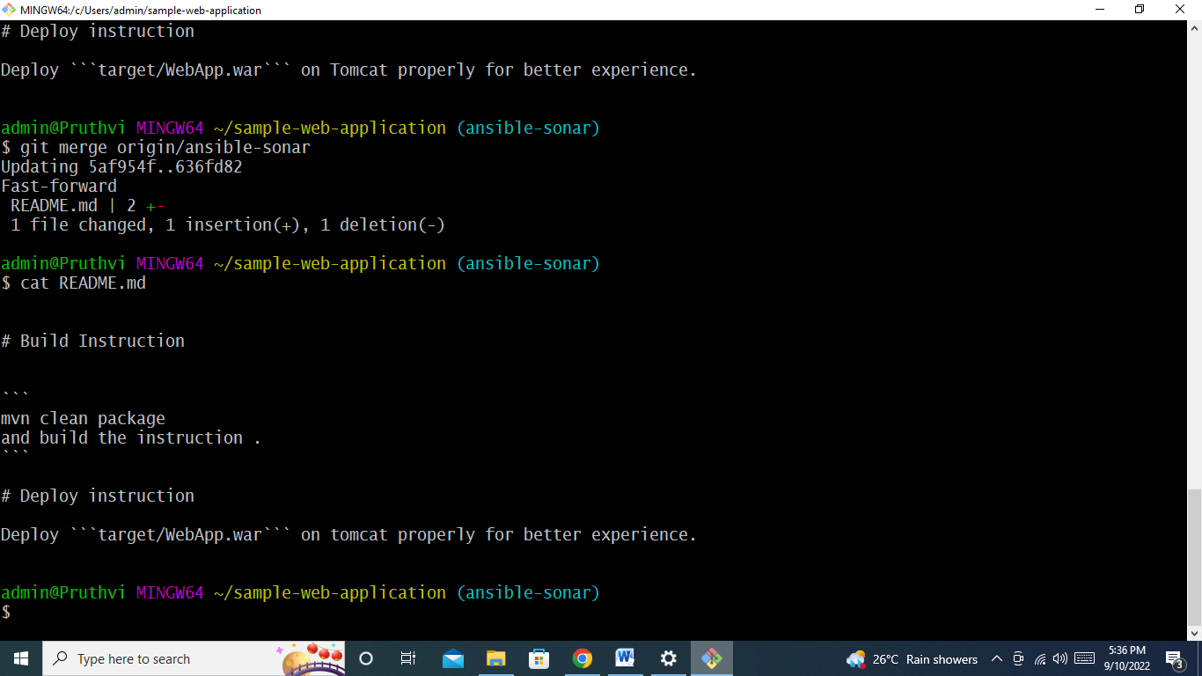

**Git pull**

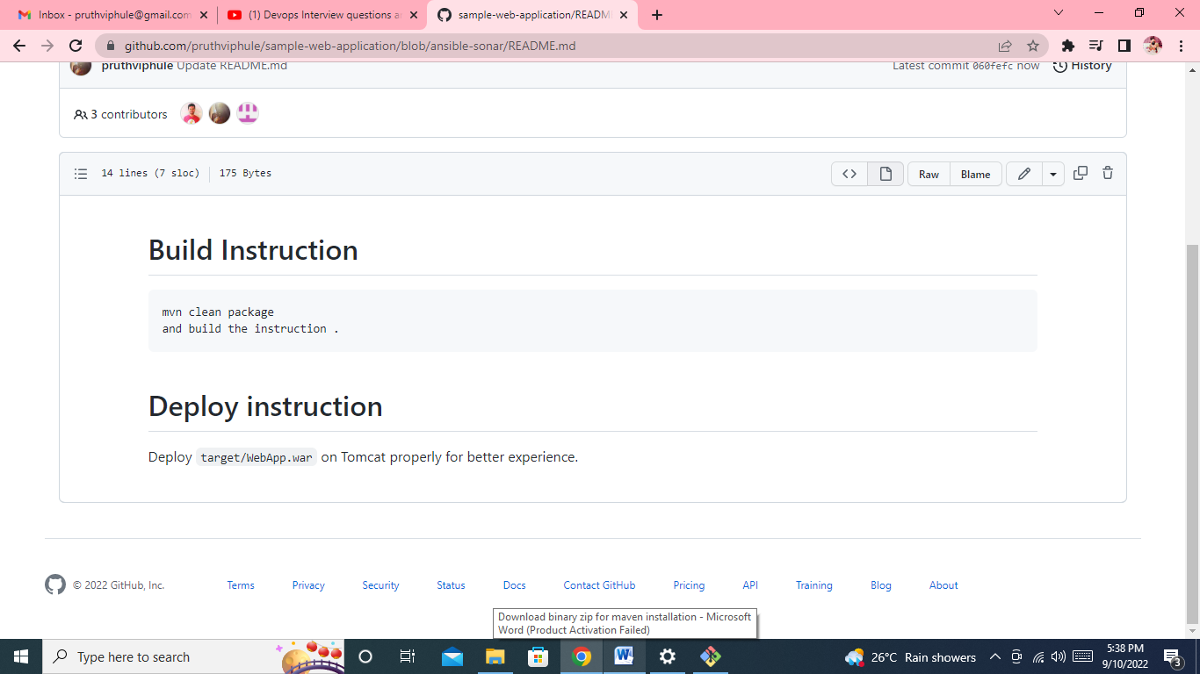

**Directly pull the changes**

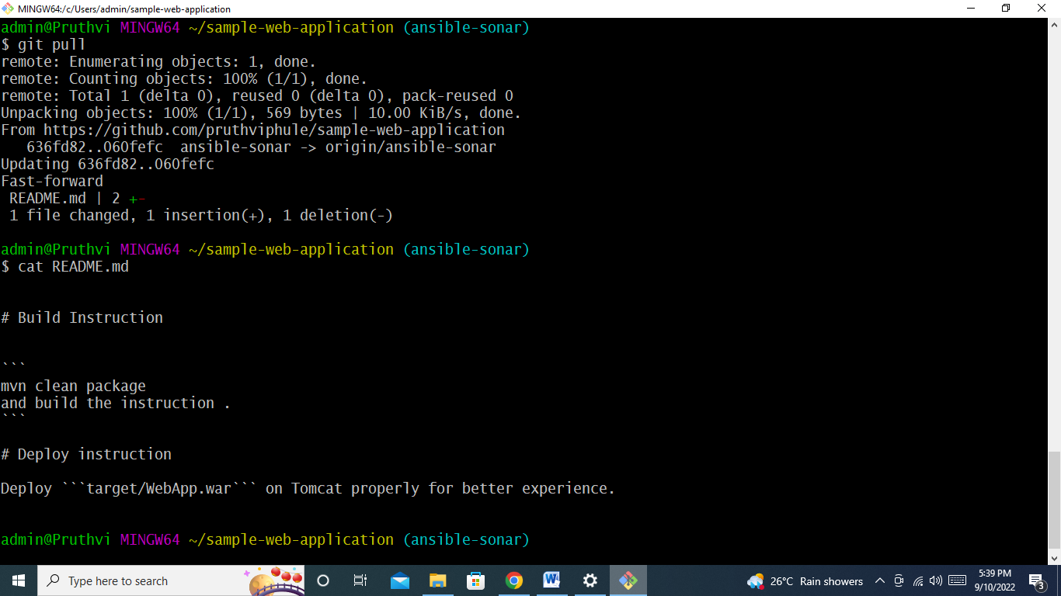

**Q.3) How to clone specific branch in GIt**

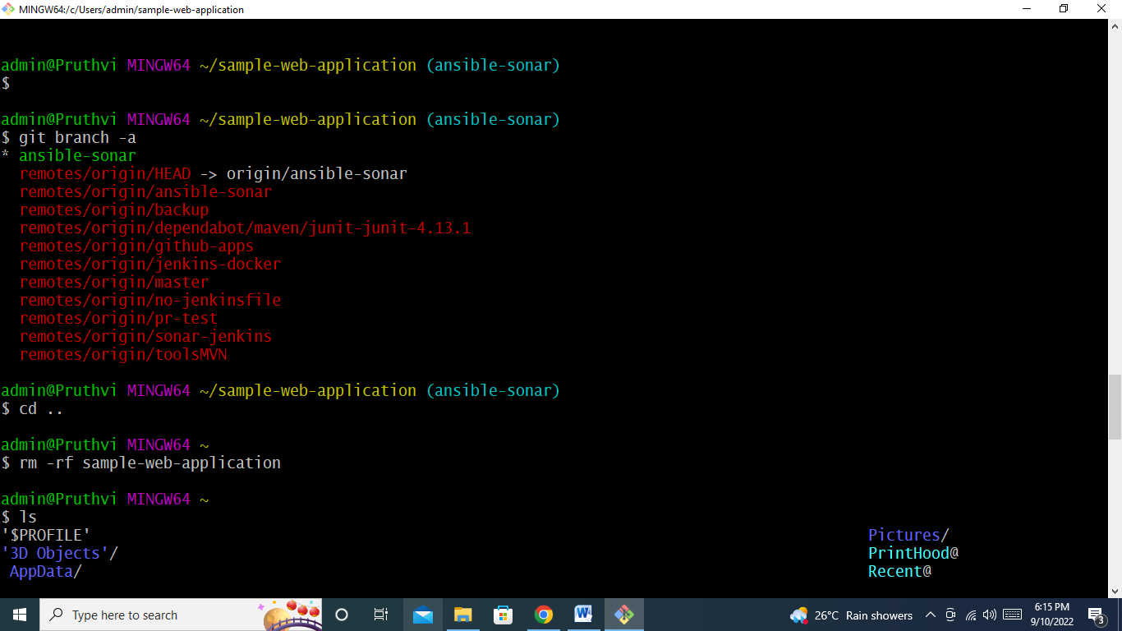

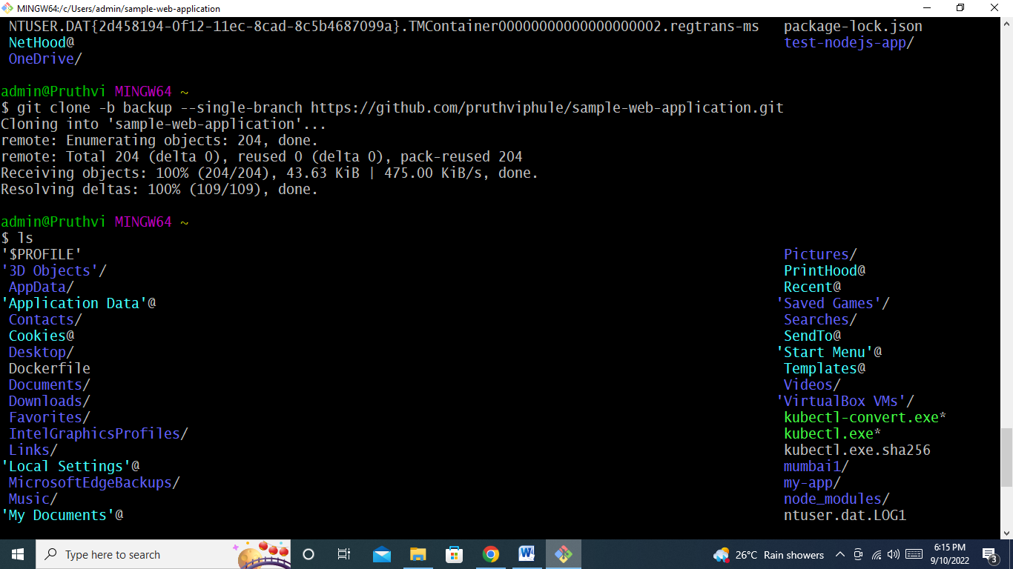

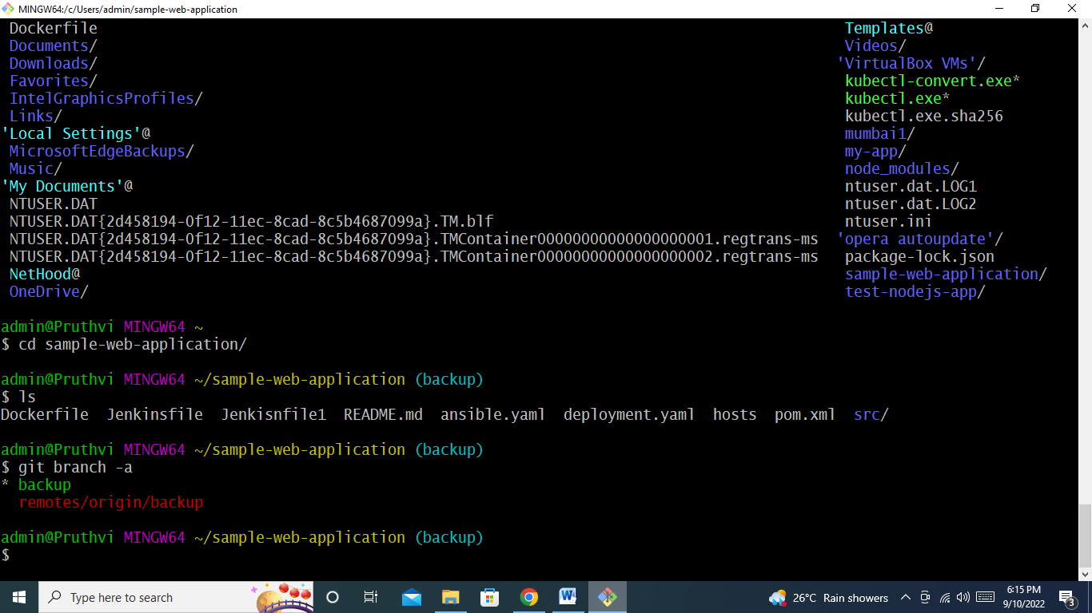

**MAVEN:**

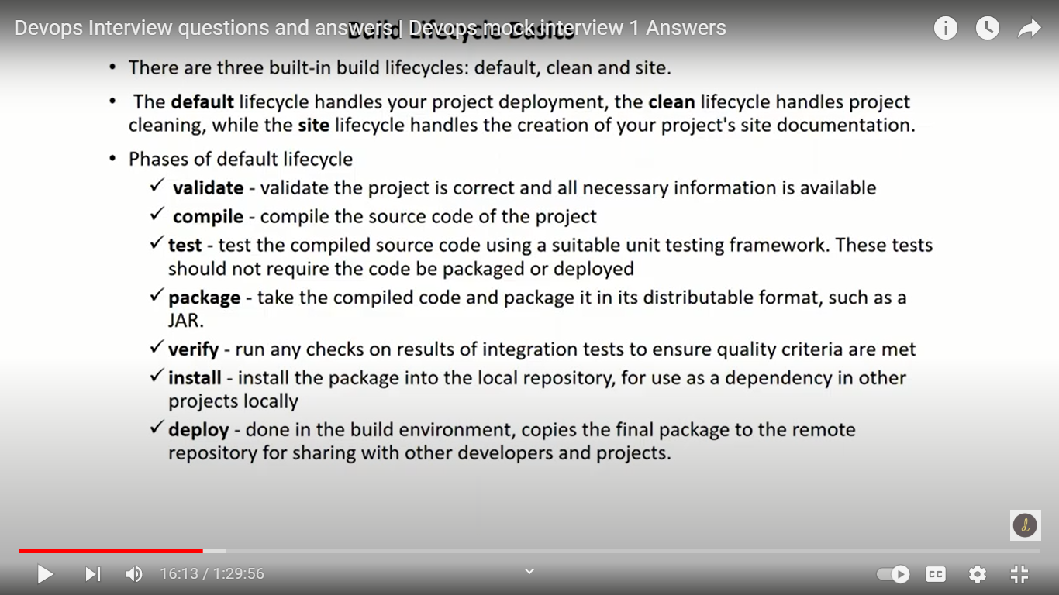

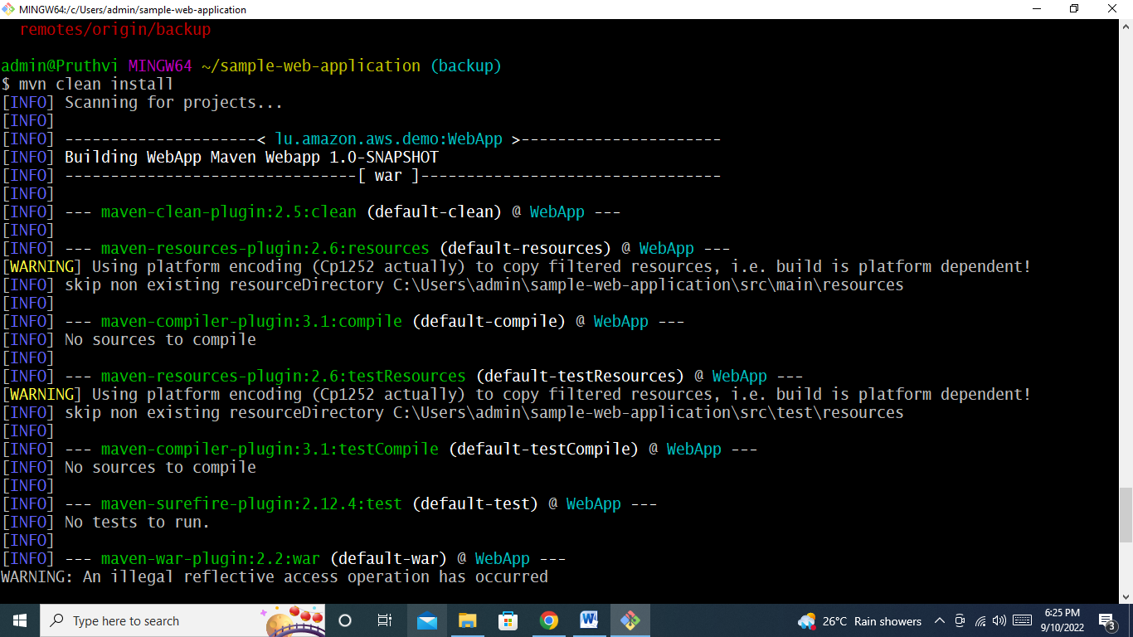

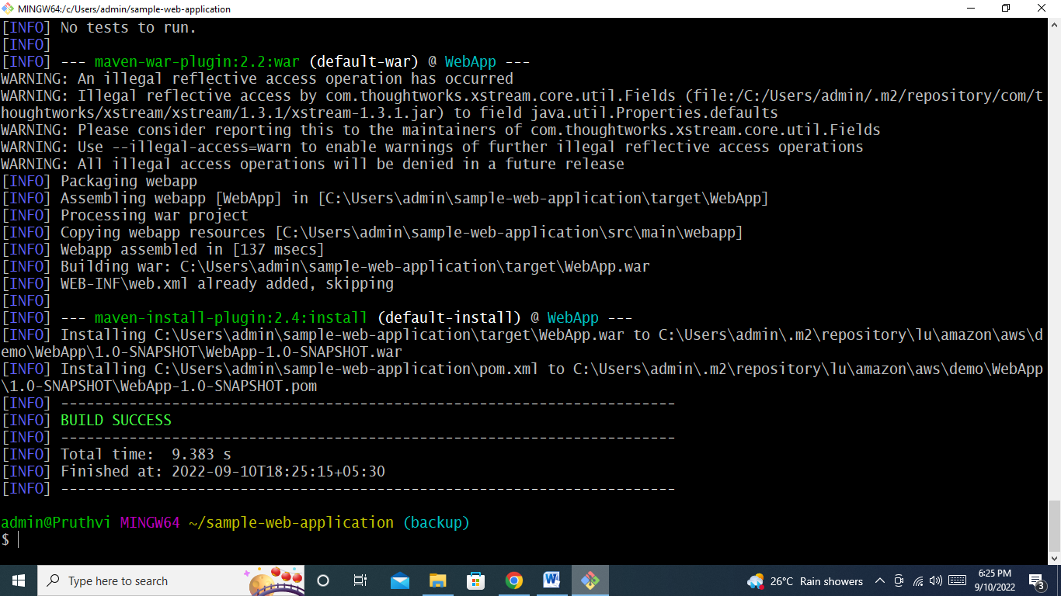

**Mvn deploy**

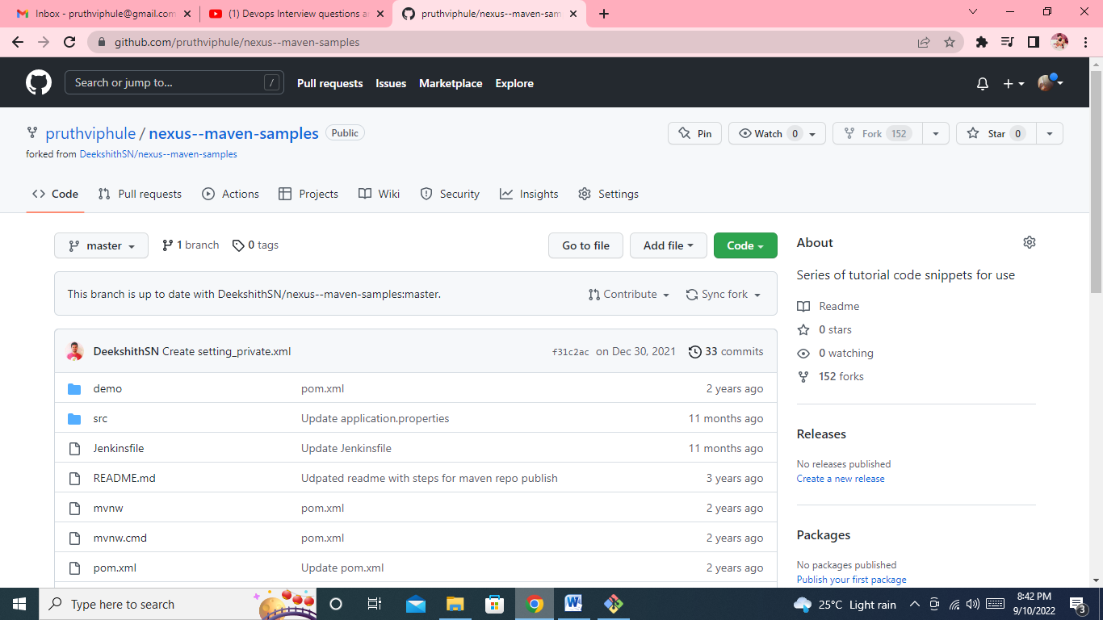

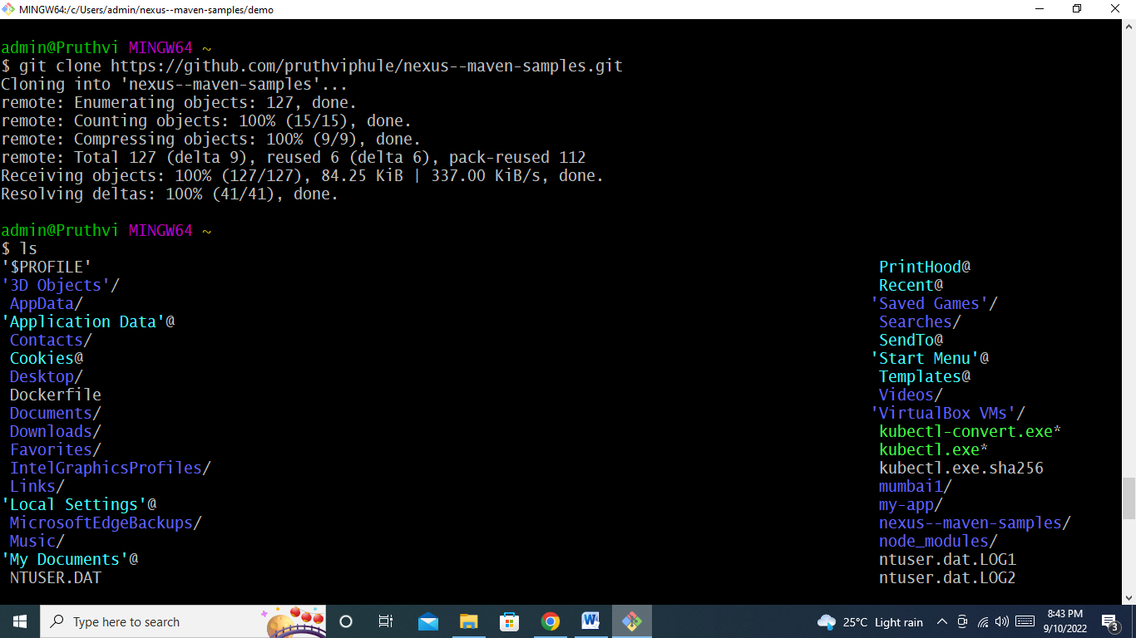

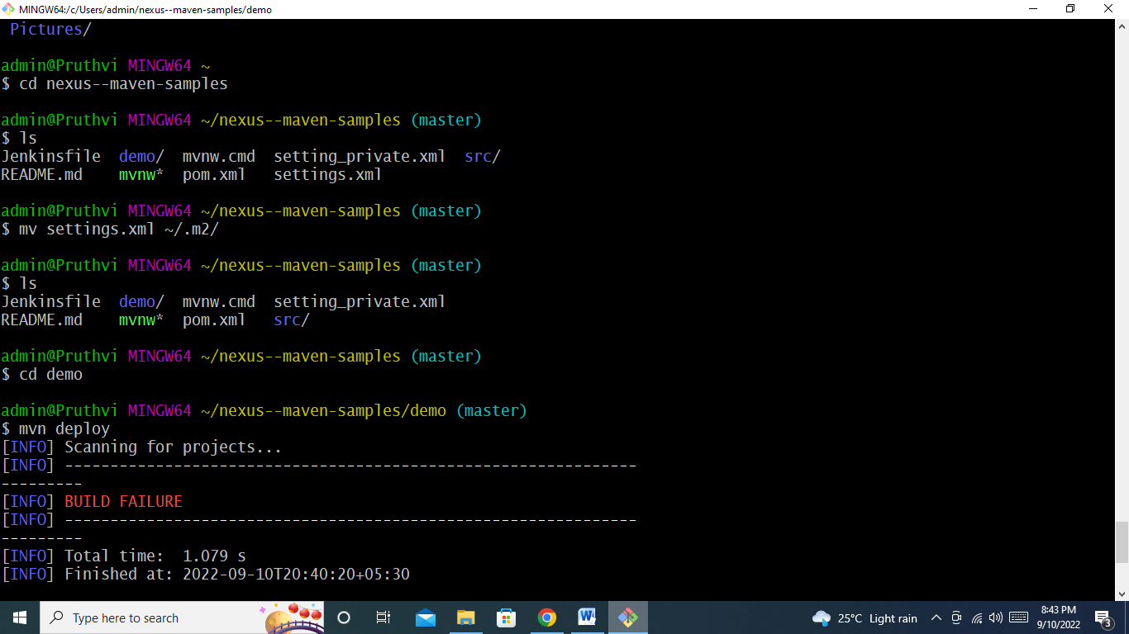

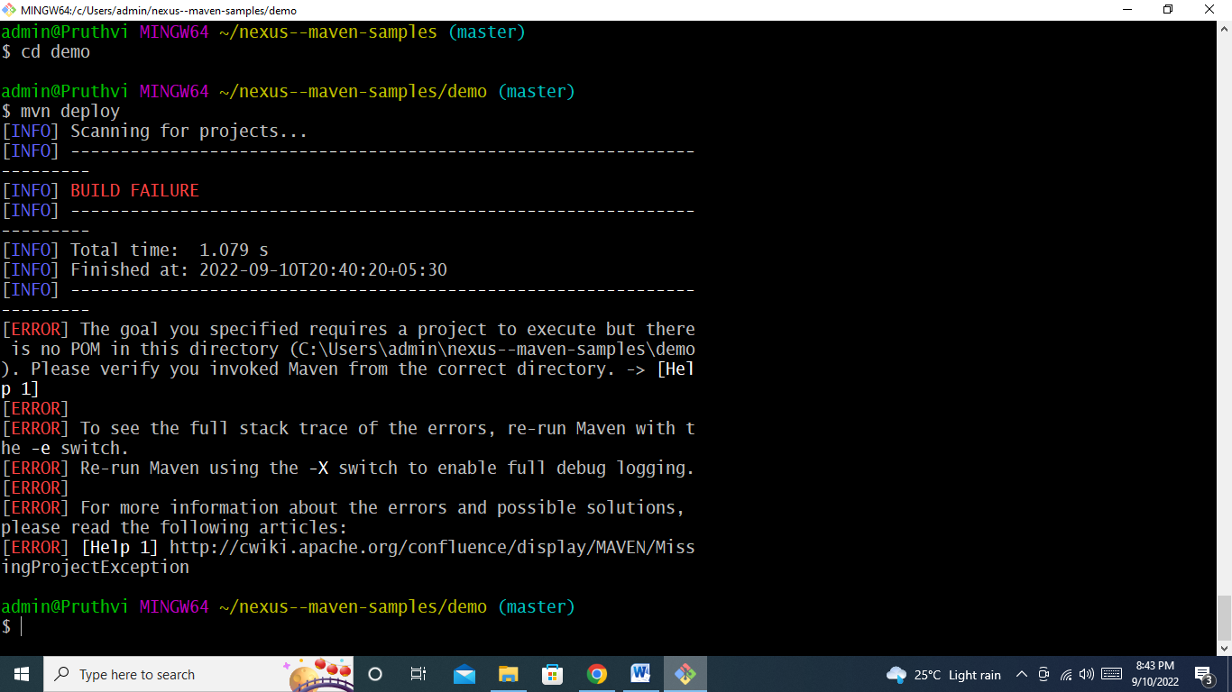

**Settings.xml and pom.xml should have same settings like id,**

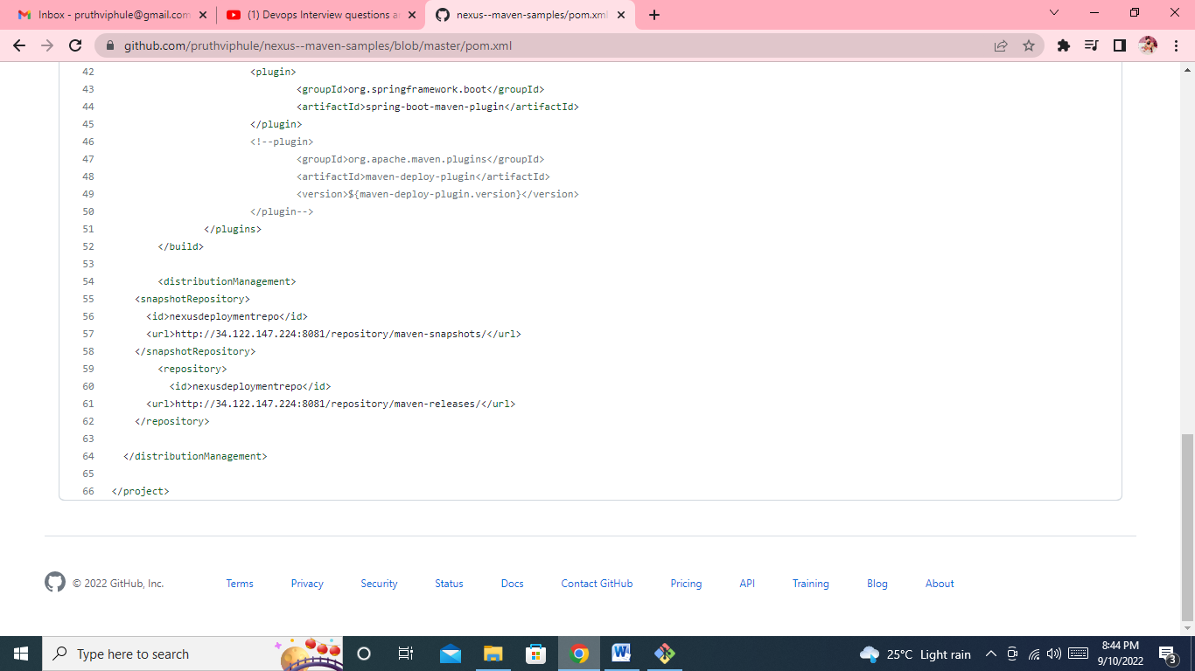

**Q. 5)** why maven takes much time for 1st execution and from 2nd execution it will take less time?

First time it will download all the dependencies and kept in m2 file….next time when we execute it, it first check locally if notfinding then download from remote repo.

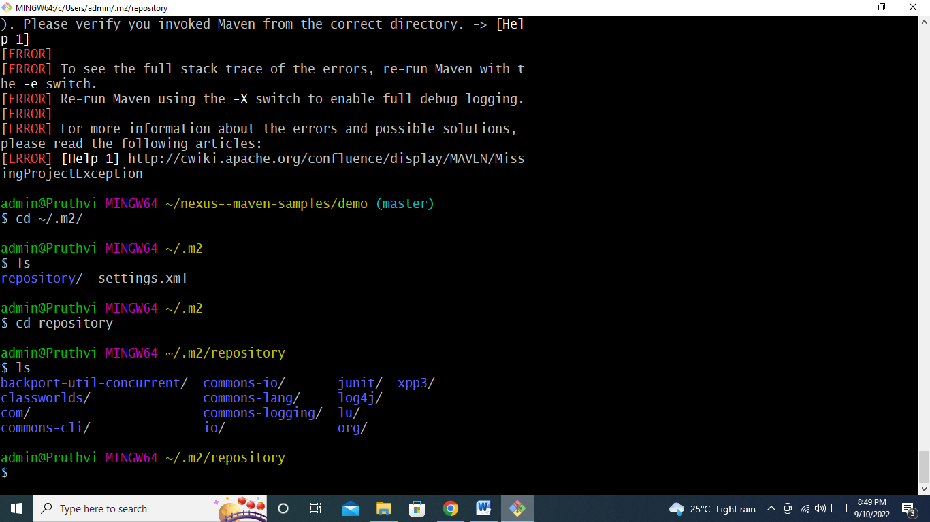

**--------------------------------------------- Unix and Shell Scripting ------------------------------------------------------------**

**8. How to get present working folder? (** not whole path)

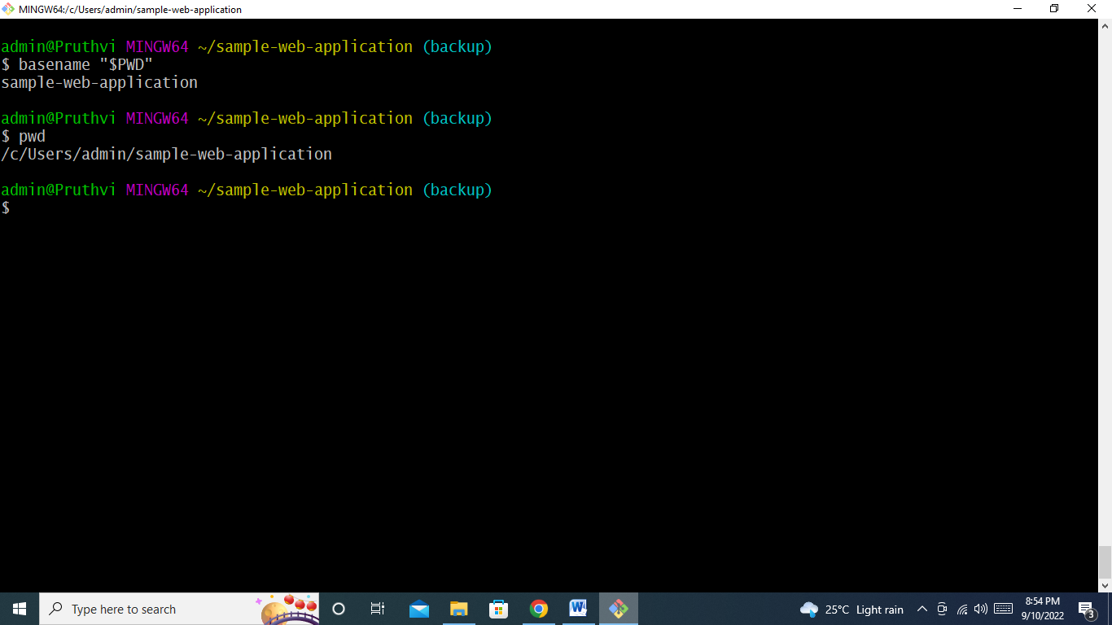

**9. How to copy files from local windows machine to cloud based Linux machine?**

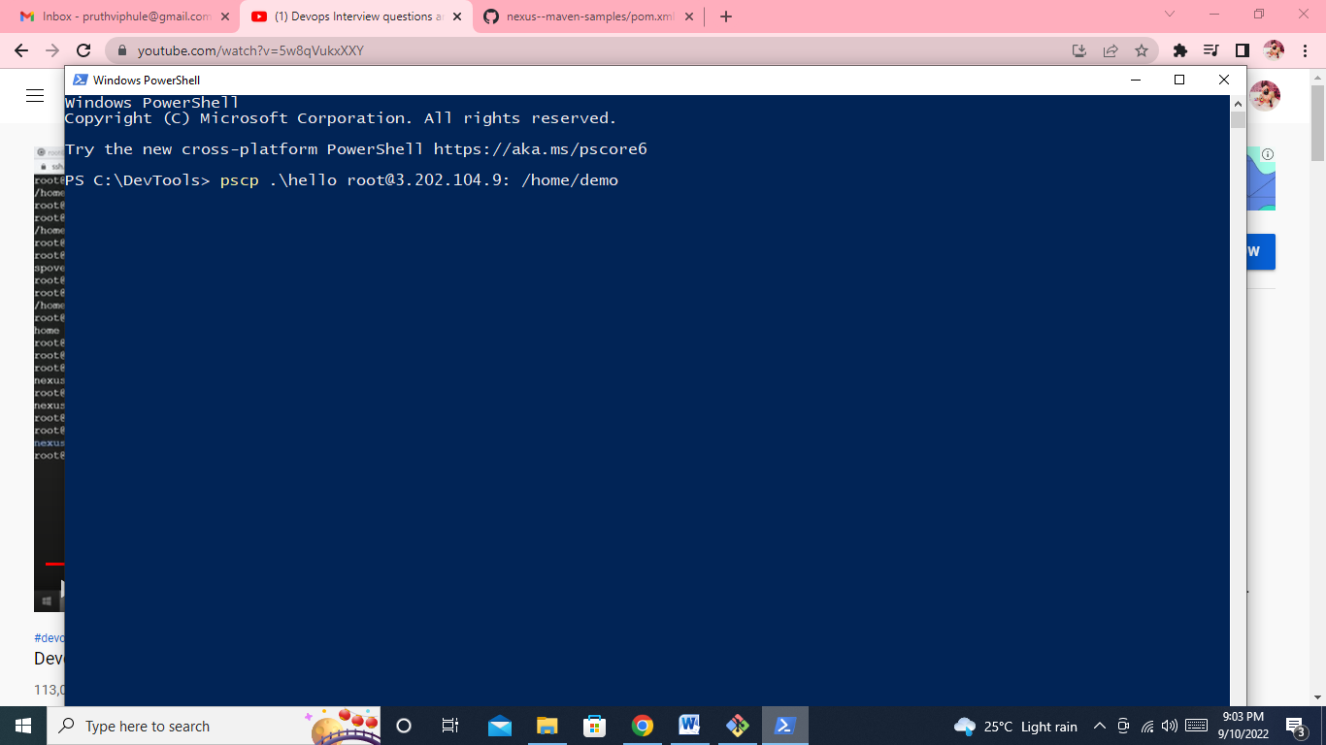

**-------------------------------------------------------Ansible--------------------------------------------------------------**

**11. Why we need ad-hoc ansible commands, scenario where you have used ansible ad-hoc command?**

Automate the single task on one or more managed nodes. Ad hoc commamds are quick and easy..but they are not reusable.

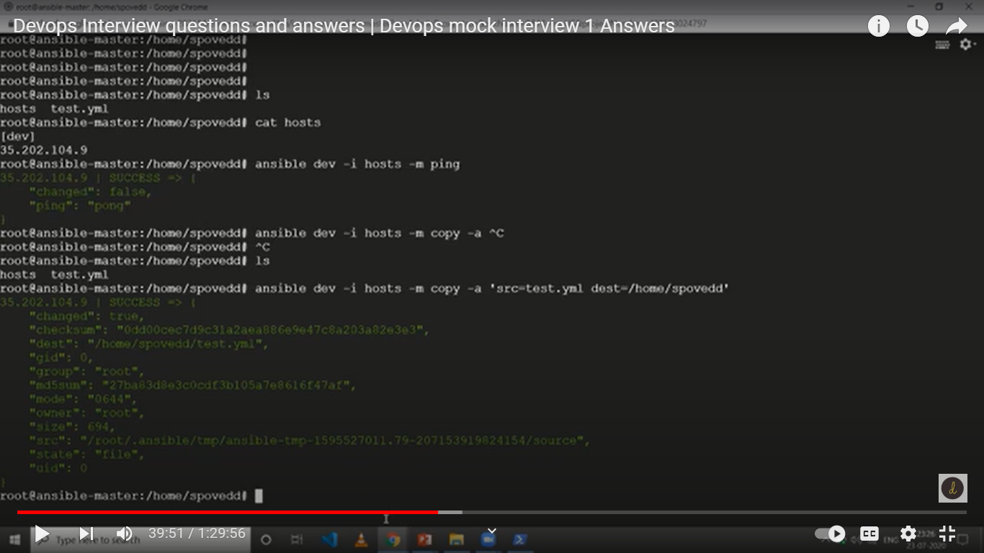

**12. When i need detailed logs on executing ansible playbook what option i need to use?**

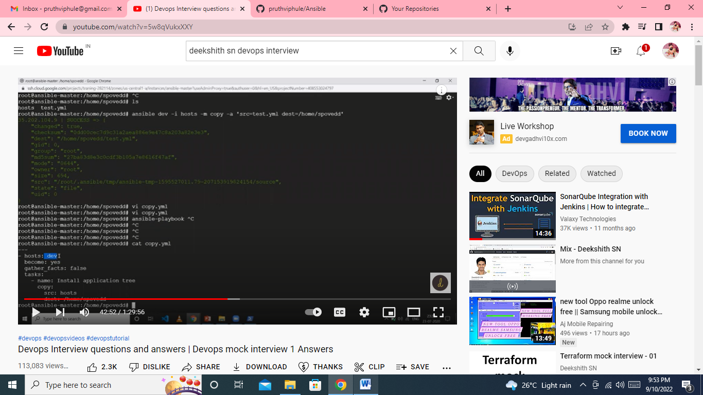

**🡪** ansible-playbook -I hosts copy.yml –vvv (for detail info /log)

**13. what is ansible.cfg file?**

Configuration file, placed under /etc/ansible/ansible.cfg

**14. what are the modules have you worked on? which module will you use for getting the file from node to master? (Fetch Module)**

1. **Copy**
2. **Fetch**
3. **Yum**
4. **Debug**
5. **Get_url**
6. **Expect**
7. **Template**
8. **File**
9. **Apt**
10. **Command**
11. **Shell**



**15. Lets say i have a playbook which has 5 tasks in playbook, first 2 tasks should run on local machine and other 3 tasks should run on node?**

-gatherfacts set to false

-gatherfacts true -> it takes all the facts about node visn and then it will store it.

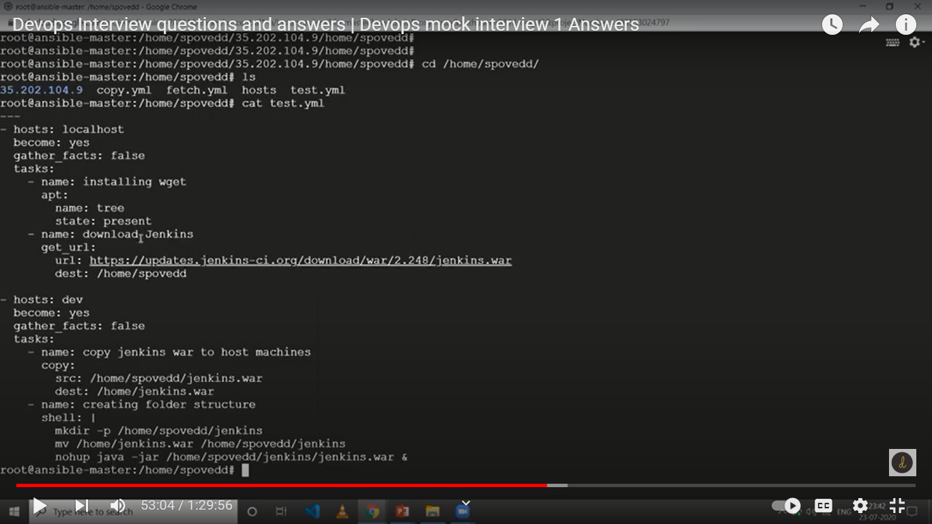

Cmd – ansible-playbook - I hosts test.yml

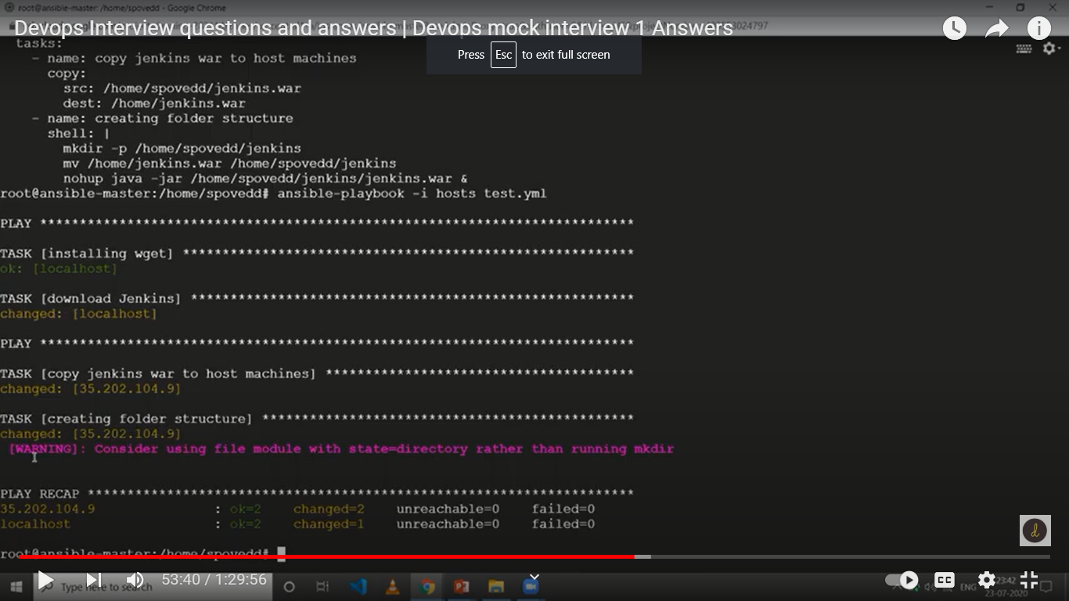

------------------------------------------------------Jenkins-----------------------------------------------------------------

**16. How to save only last 5 builds of jenkins job?**

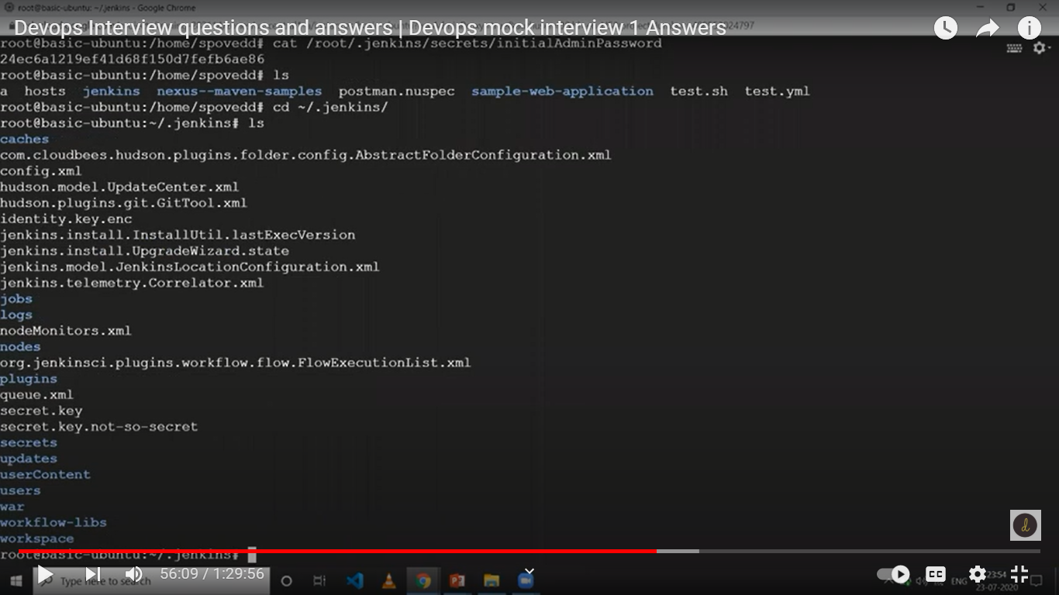

**Linux:**var\lib\jenkins

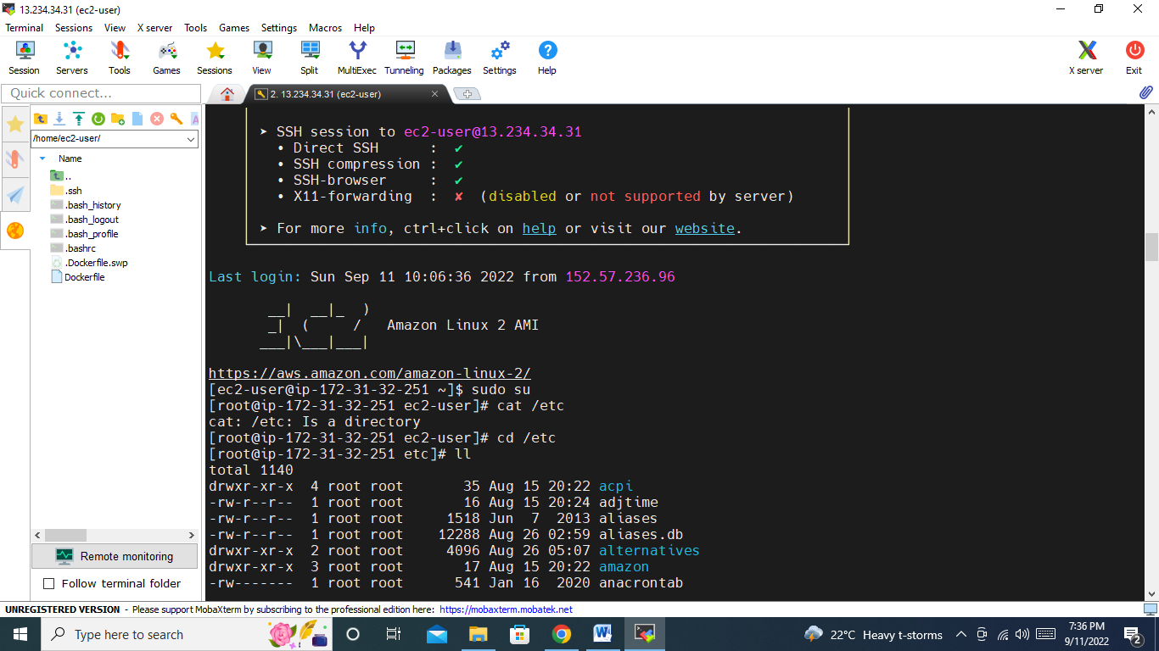

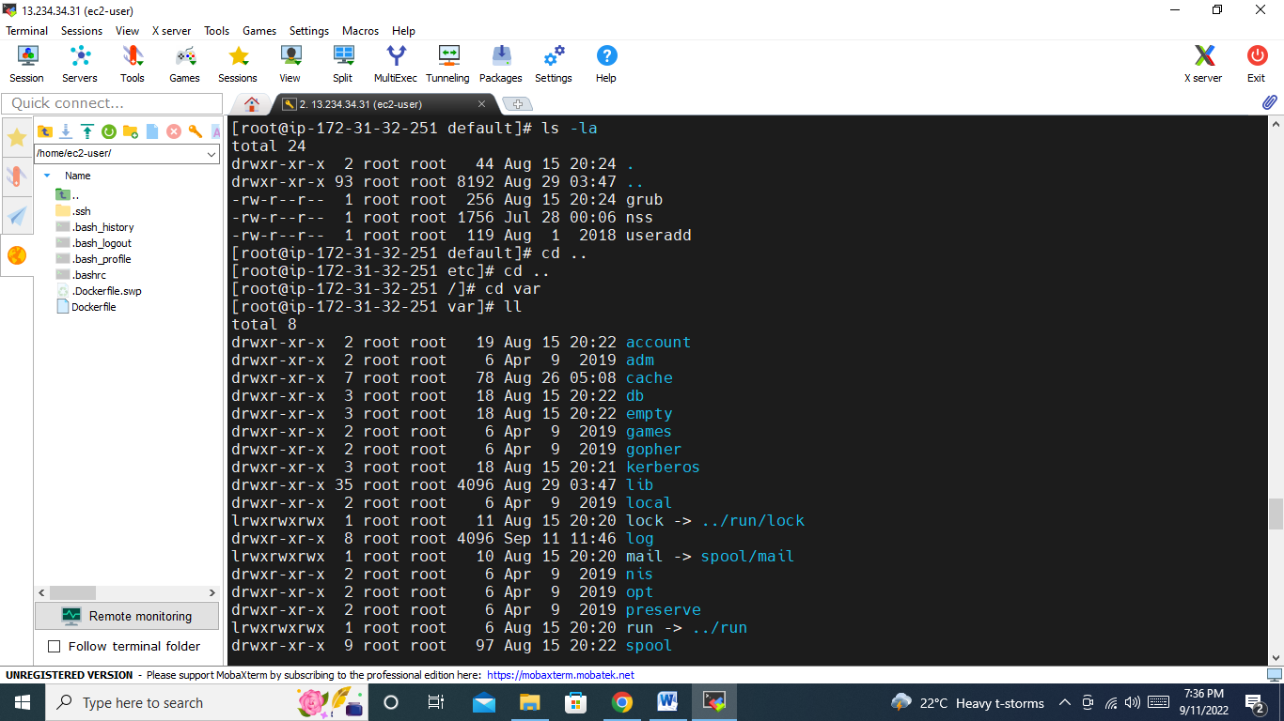

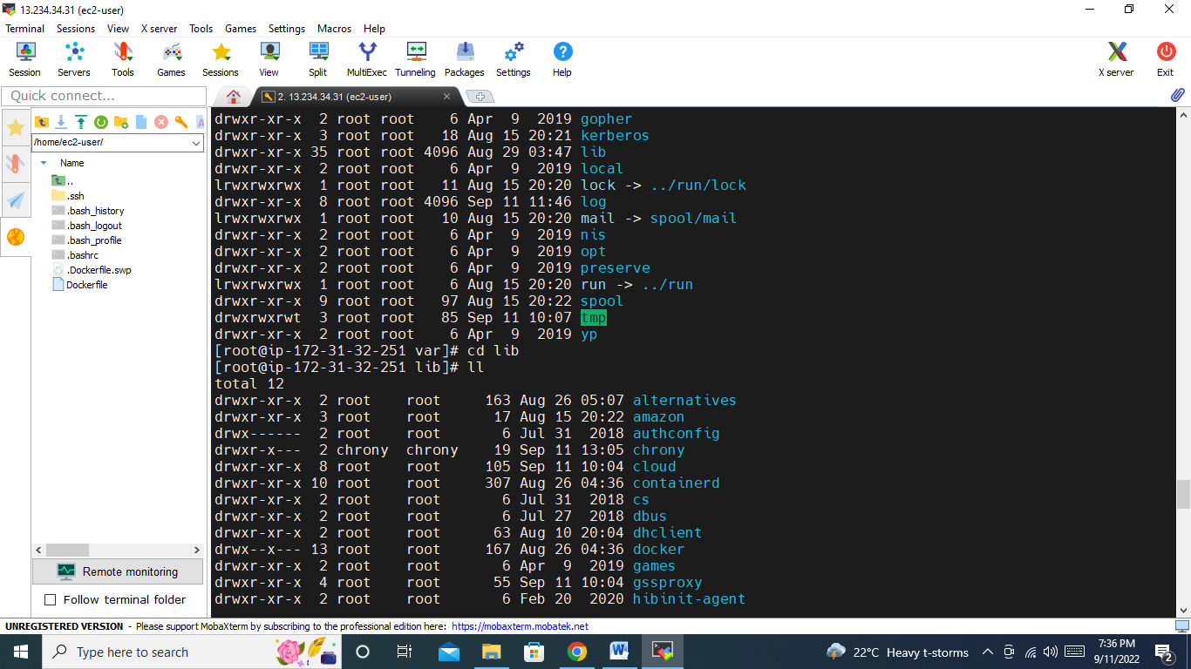

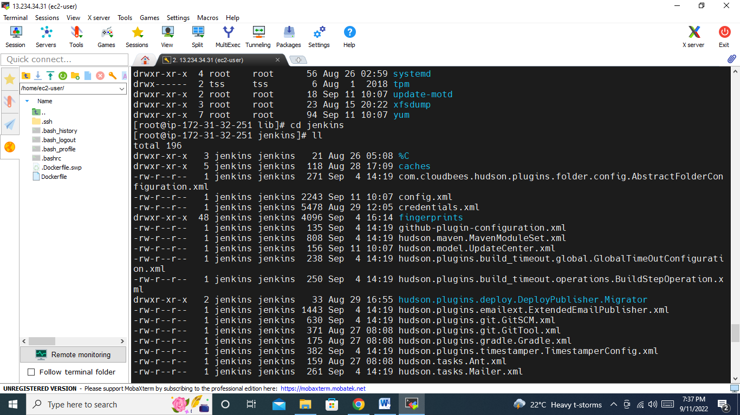

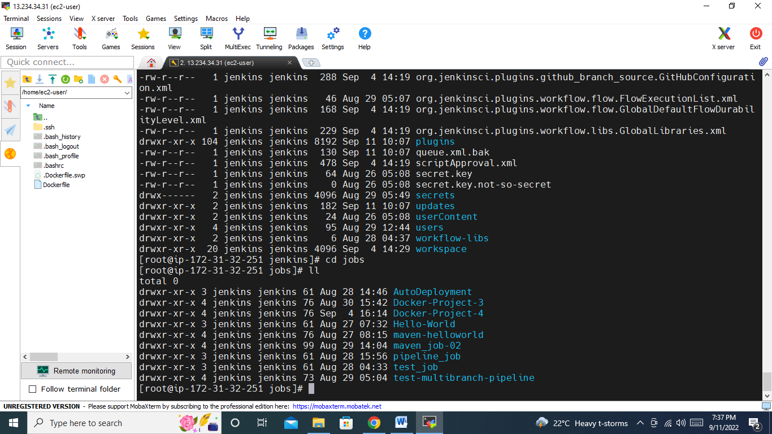

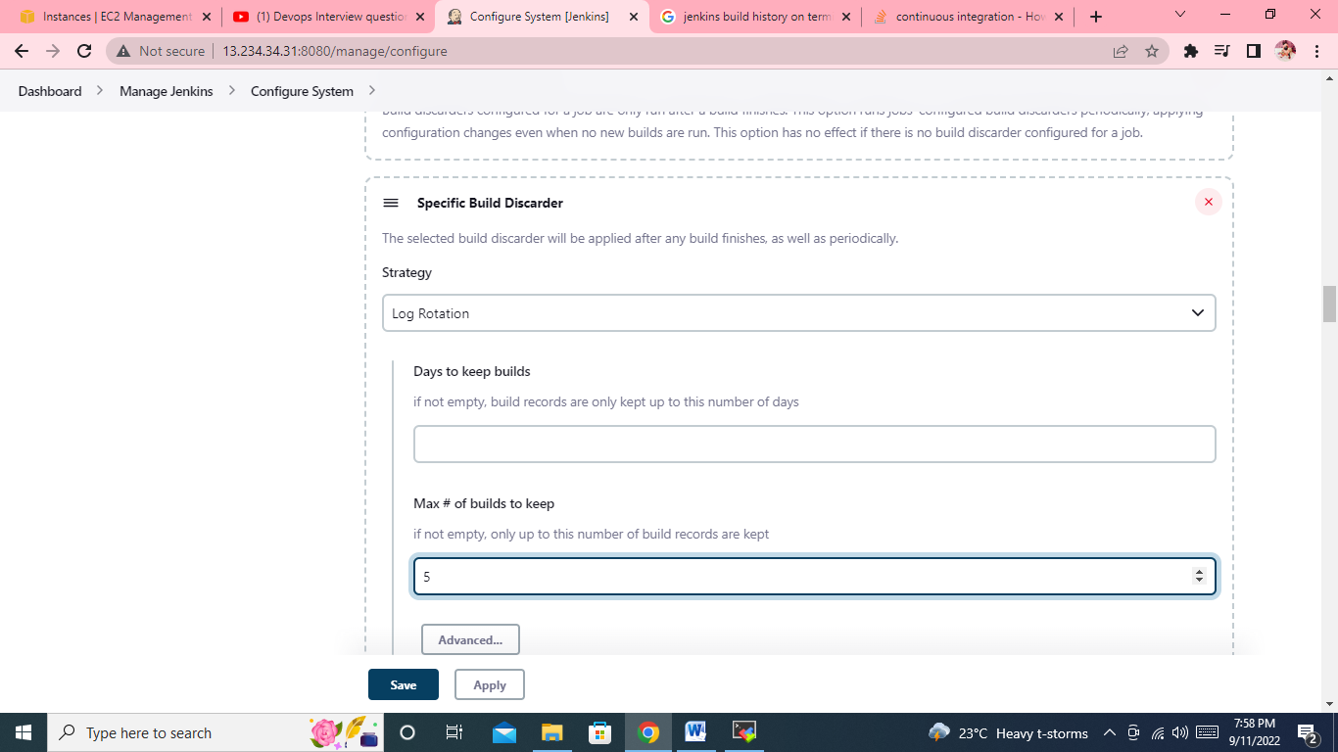

17. Have you worked on Jenknsfile? can we use docker container as a node in Jenkinsfile? Who will handle docker container creation and deletion? If i am building a maven project always docker container is fresh instance it will try to download dependency from repository, what measures you will take to reduce build time?

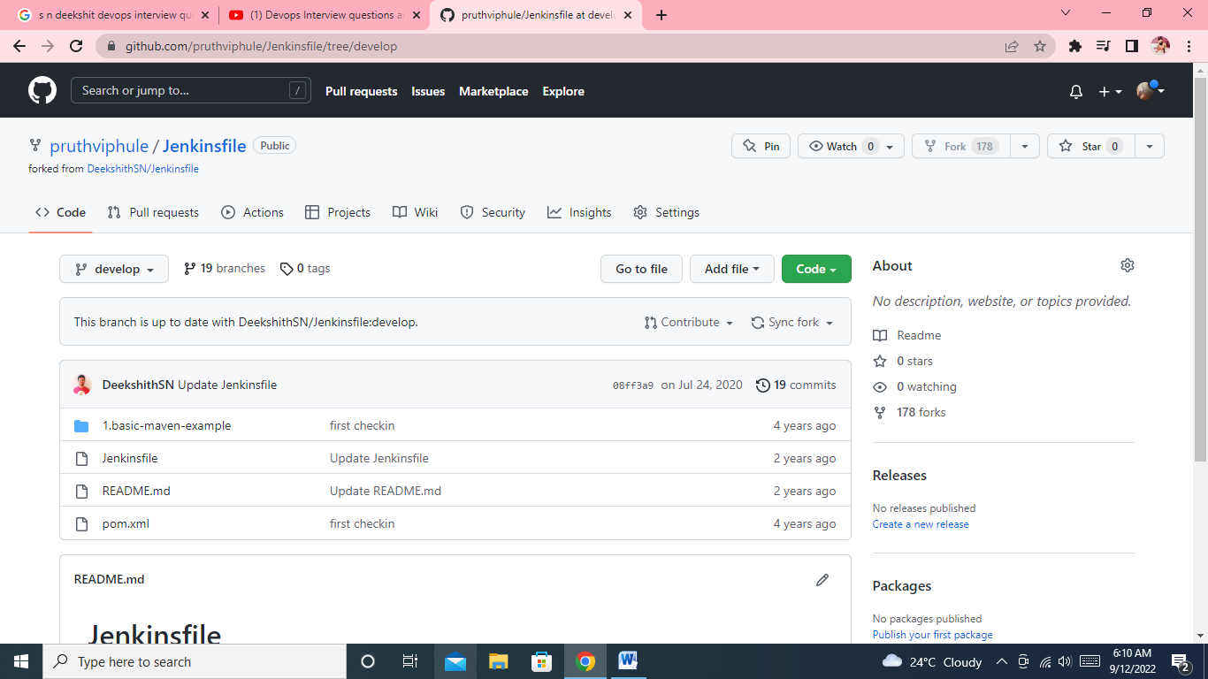

**Path for workspace**

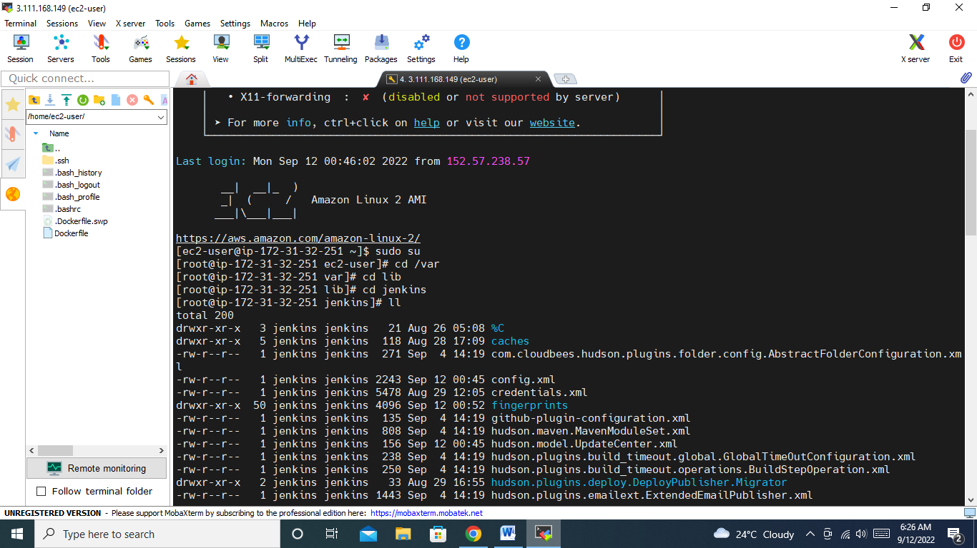

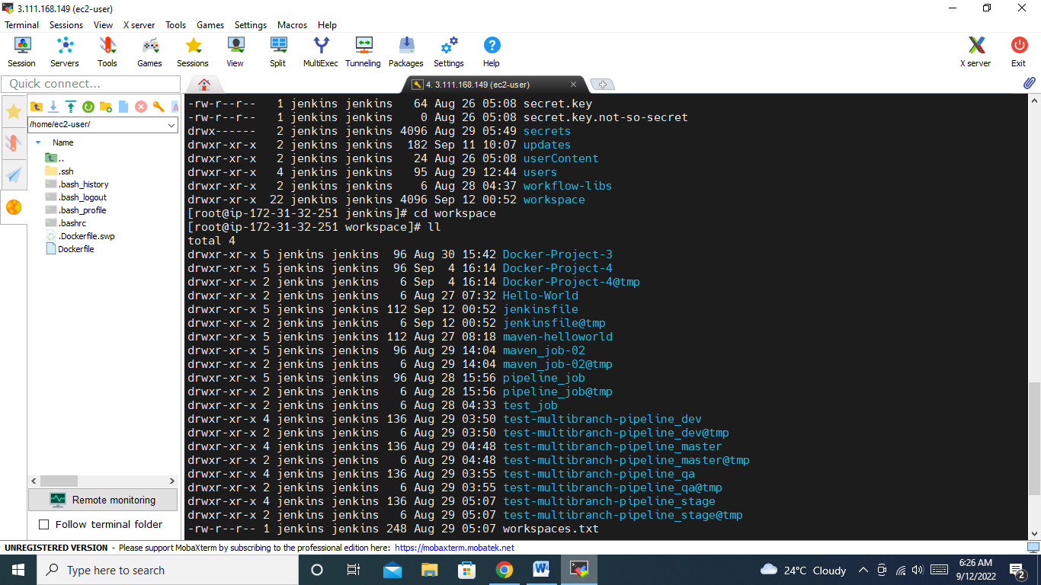

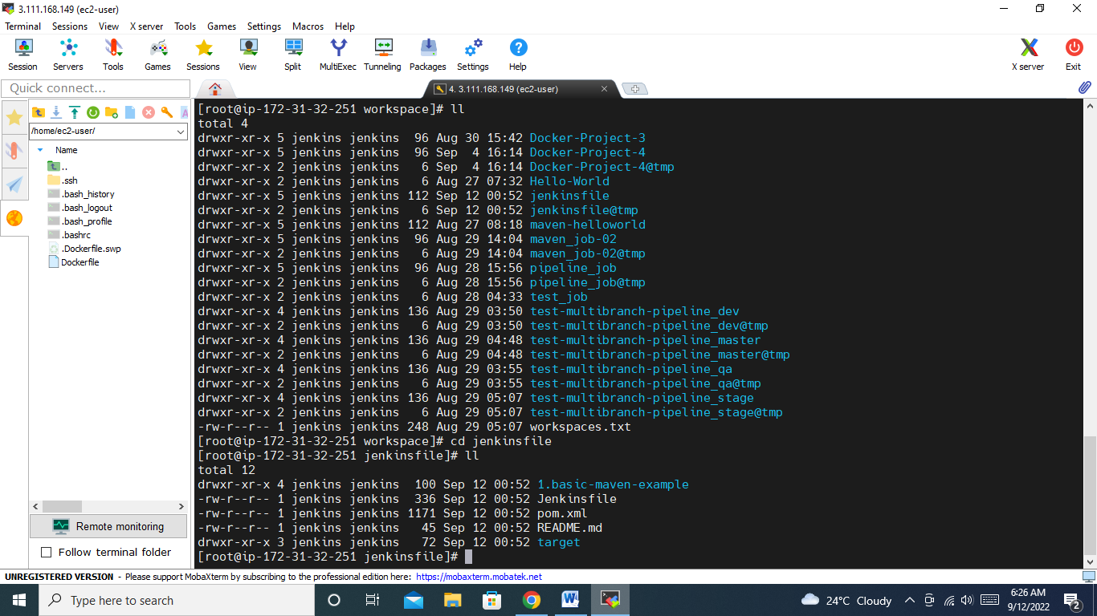

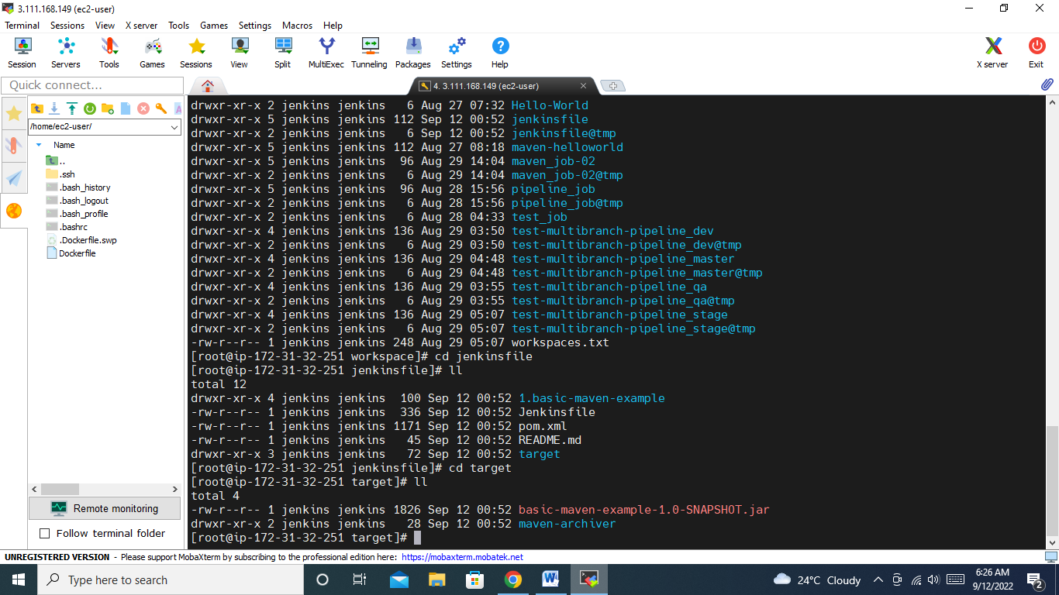

**18. Why we need multi branch pipeline?**

**🡪** Jenkins automatically discovers, manages, and executes pipelines for branches which contain a jenkinsfile in source control.

**19. If you forget Jenkins password, how would you login back?**

**->** make useSecurity to false in /var/lib/Jenkins/config.xml

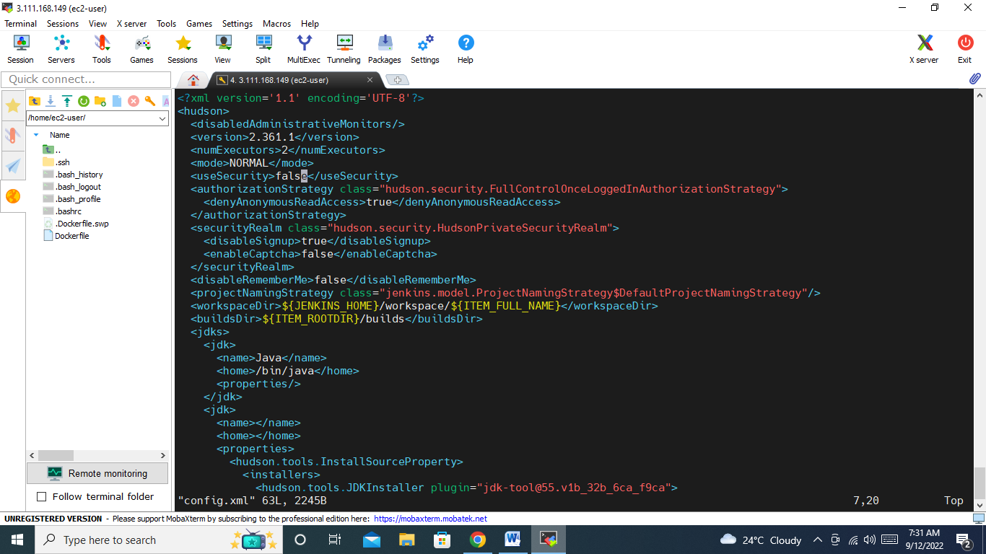

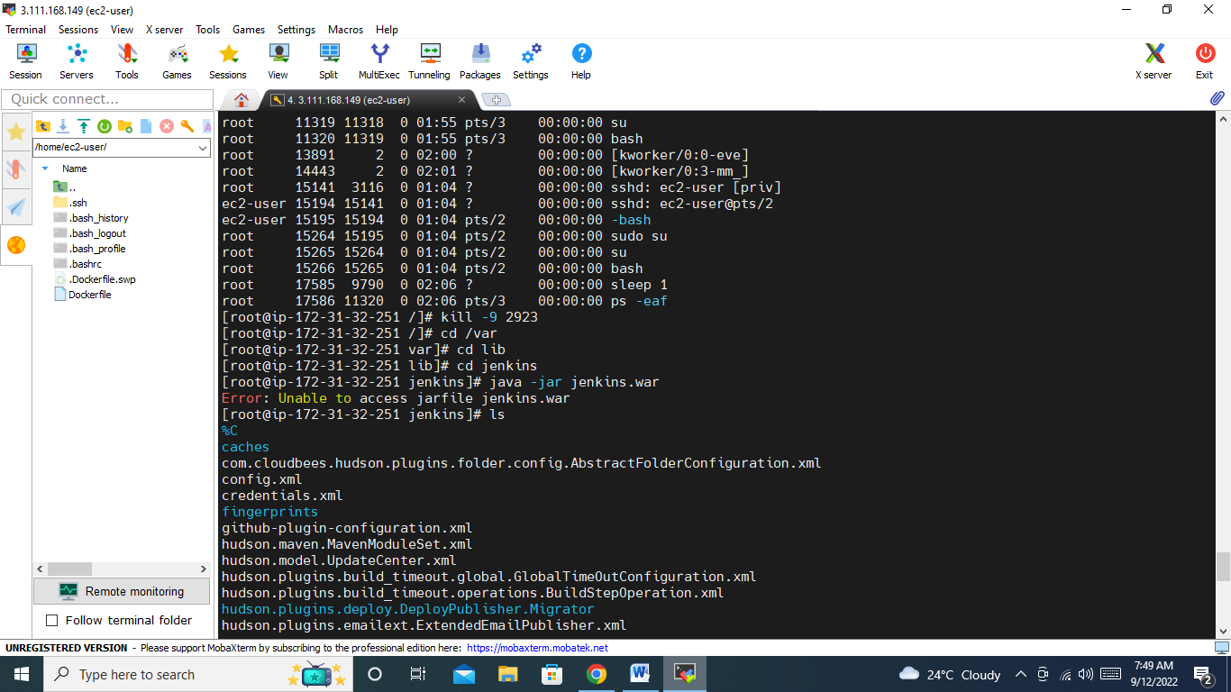

-------------------------------------------------------Docker-----------------------------------------------------------------------

**20. Any 3 best practices of docker?**

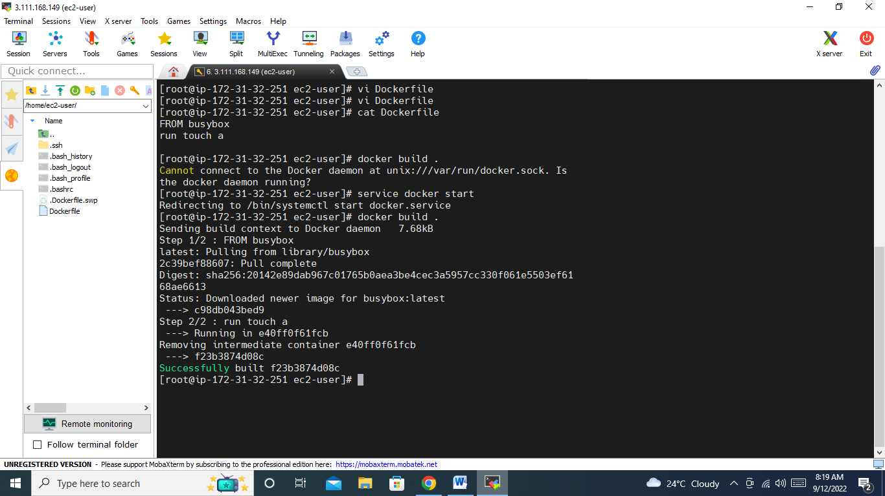

- Always place dockerfile in empty directory.

- use official images if possible

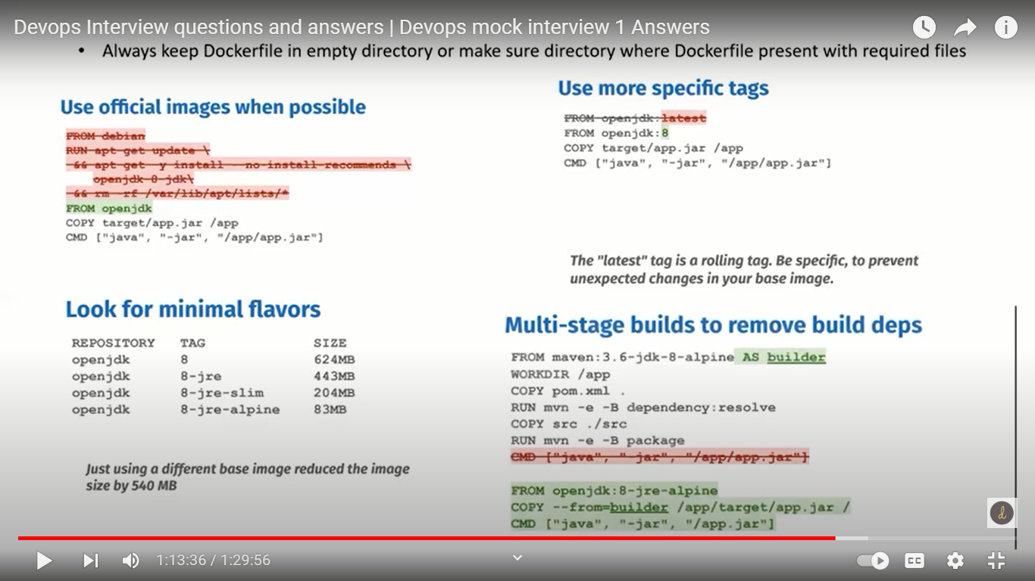

**21. Difference between docker stop and docker kill?**

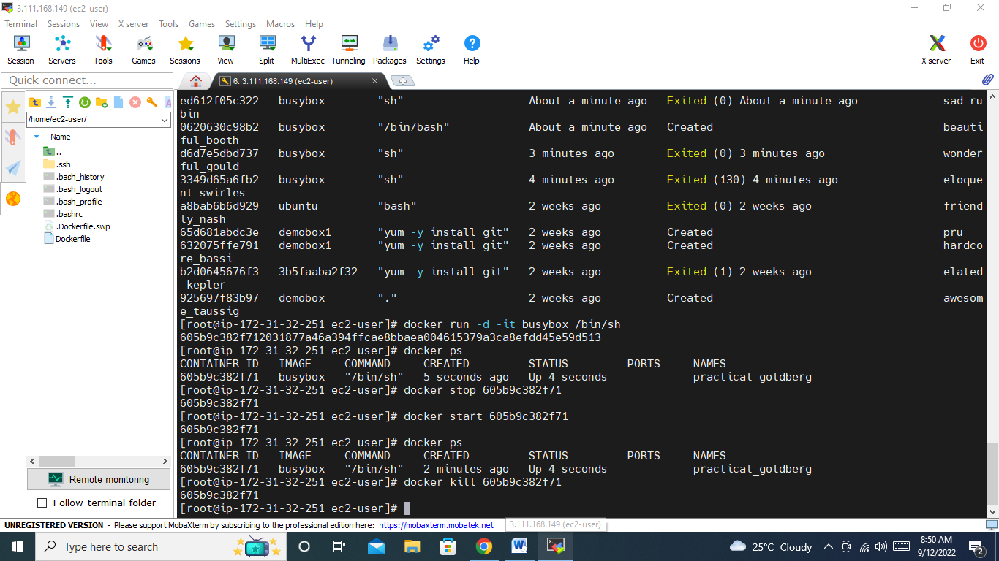

docker stop – it take signal 15 then signal 9 – take some grace period to stop the container

docker kill – it takes signal 9 directly… not having much grace period.

**22. Command to list conatiners which state is exited?**

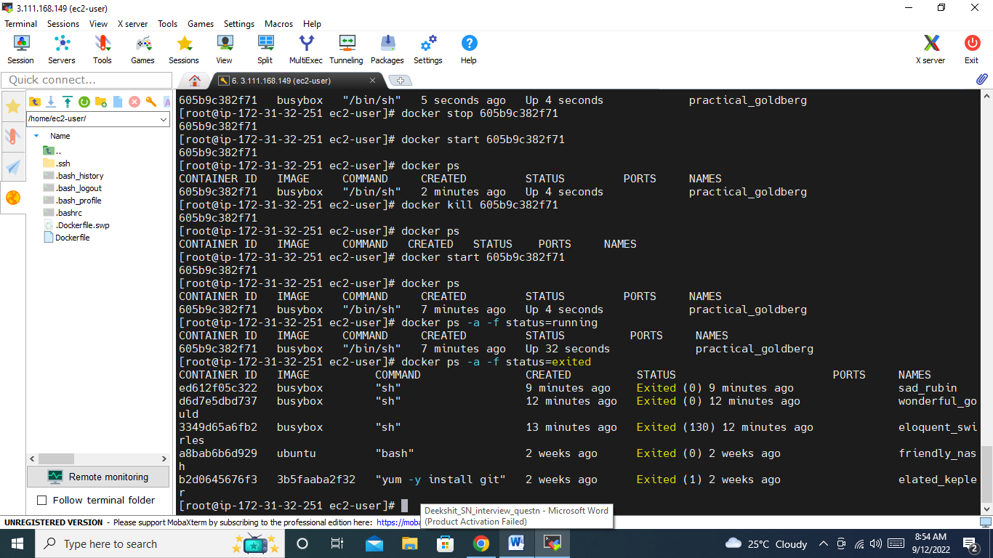

**23. command to clean-up docker host ( deleting stopped conatiners, dangling images and unused networks)?**

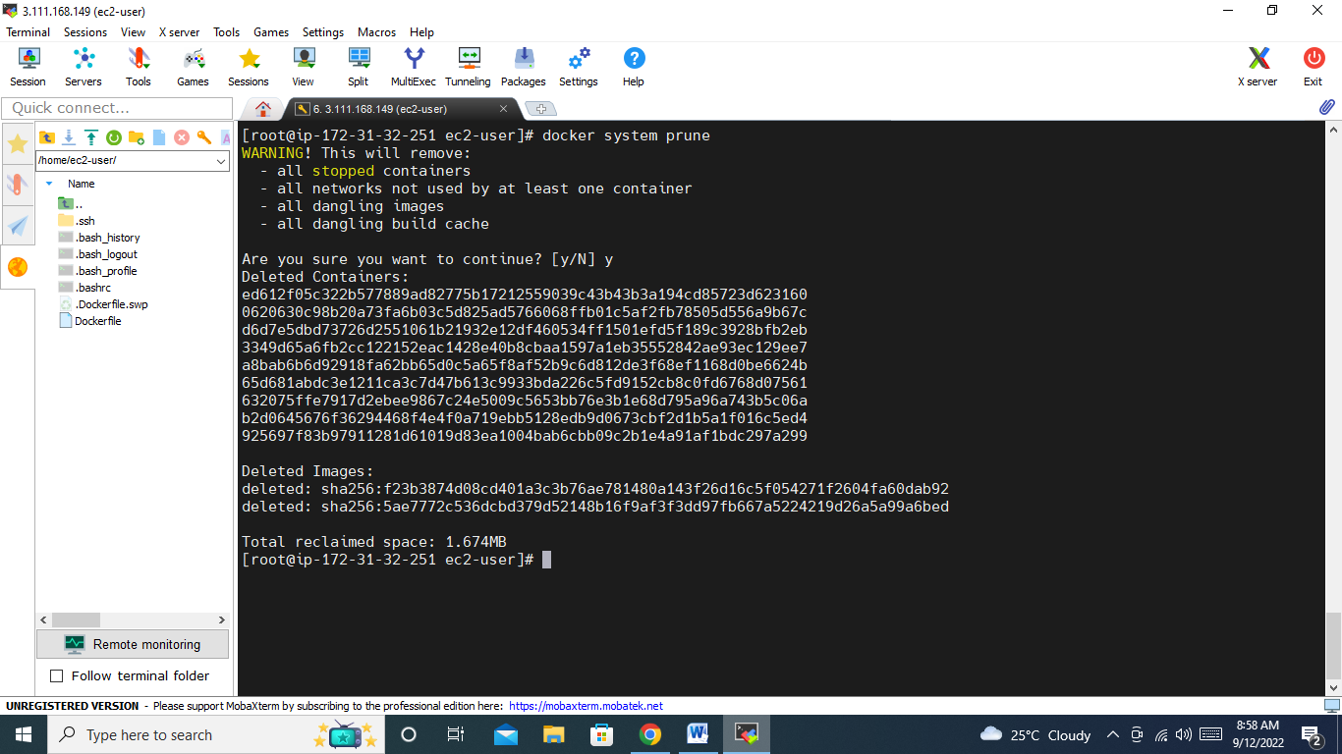

**24. What version of docker you have used? Specific reason to use that particular version?**

-> Docker version 20.10.17, build 100c701

**25. Can we have multiple CMD in Dockerfile?**

-> yes , we have but no use because it only takes last CMD.

**26. Have you worked on docker swarm and docker compose?**

**-> docker swarm :**it allows to manage multiple containers deployed across multiple host machines

**-> docker compose:** compose is tool for defining and running multi-container docker applications.

-------------------------------------------------------------Kubernetes-------------------------------------------------------------------------

**27. Can we have multiple conatiners in a pod? Can we have similar conatiners in a pod? Lets say i have 4 conatiners, one of them has failed how would you check which container has failed?**

Can we have multiple conatiners in a pod? -> yes

Can we have similar conatiners in a pod? -> no

Lets say i have 4 conatiners, one of them has failed how would you check which container has failed?

- Install kubectl

- kubectl get all

- kubectl describe pod pod-name

If exit code is zero, then applicant is successfully running.

**28. What is liveness and readiness probe? Why we need them?**

-> to mke the application highly available

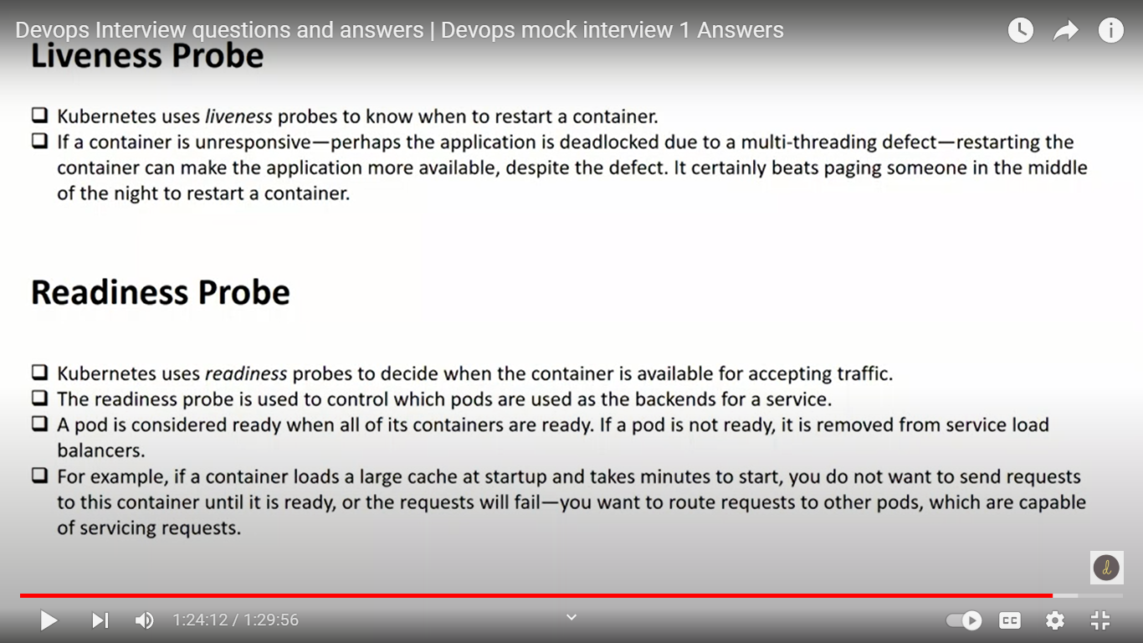

**29. Have you worked on kubernetes monitoring? Which tools you have used?**

-> promethius and graphana

**30. Can we deploy a pod on particular node?**

-> yes

Node selector

Node affinity

Tolerations

